Enkhmaa Buyanbadrakh
July 22nd, 2024

End of Summer FURSCA Report 2024

This summer, my research project aimed to investigate the significant decline in accounting graduates reported by the American Institute of Certified Public Accountants (AICPA) since 2021. The primary goal is to explore the underlying reasons behind this trend and propose effective strategies to revive interest in the accounting profession. By analyzing recent trends in accounting education, including shifts in student perceptions, technological advancements, economic factors, and other indirect factors, this study aims to contribute meaningful insights to accounting education and the profession, with the ultimate goal of encouraging a revived and sustained interest in pursuing accounting careers in the U.S.
Throughout the summer, I successfully gathered and analyzed data from the AICPA and The CPA Journal to track enrollment and graduation trends over the past 10 years. Additionally, I collected graduation rates for a period of ten years from 61 private colleges and public universities offering bachelor's degrees in accounting using data from datausa.io.
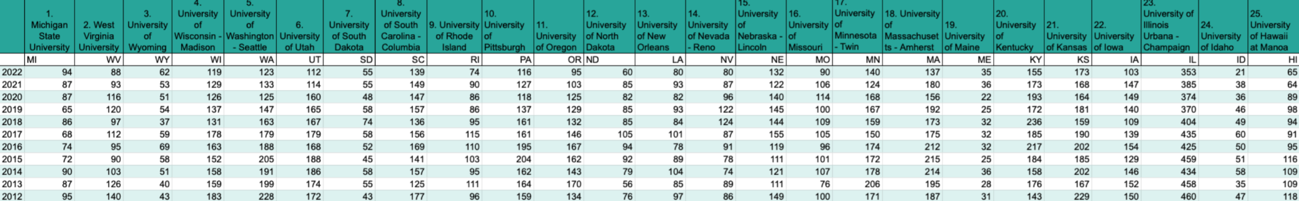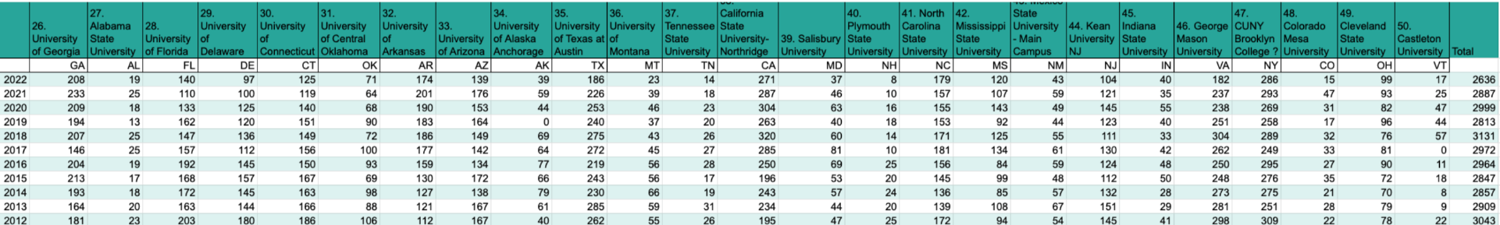Figure 1. Trends in Accounting Graduates from Various U.S. Universities (2012-2022). Source: https://datausa.io/
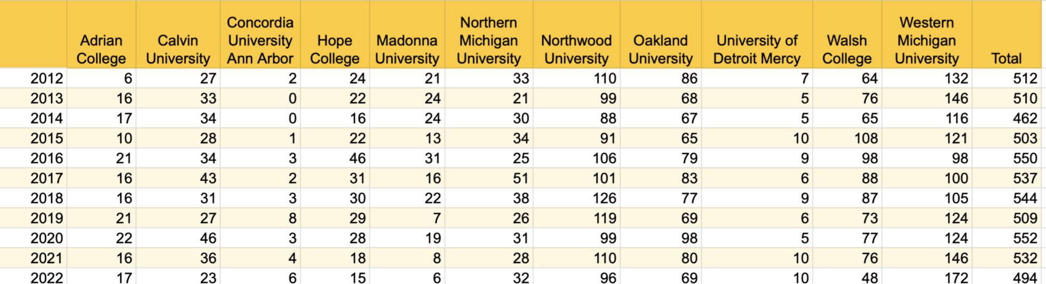
Figure 2. Trends in Accounting Graduates from Private Colleges in Michigan (2012-2022) Source: https://datausa.io/
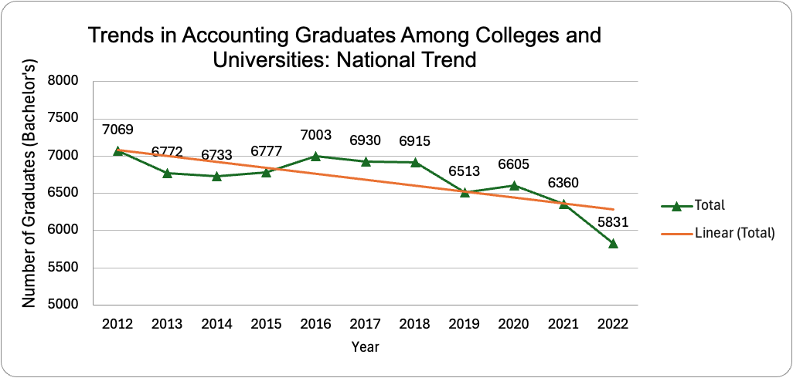
The graph illustrates the trends in accounting graduates among 11 private colleges and 50 public universities from 2012 to 2022, highlighting a clear downward trend. Initially, there was a decrease from 7,069 graduates in 2012 to 6,772 in 2013, marking an early decline. The numbers fluctuated between 2013 and 2016, with a low of 6,733 in 2014 and a peak of 7,003 in 2016. However, from 2017 onwards, the trend generally pointed downwards, with graduates decreasing from 6,930 in 2017 to 6,513 in 2019. There was a temporary increase in 2020, with 6,605 graduates, potentially reflecting delayed impacts of external factors. The most significant drop occurred between 2021 and 2022, from 6,360 to 5,831 graduates, the lowest point in the decade.
The linear trend line further emphasizes the overall decline in the number of accounting graduates over the ten-year period. The consistent downward slope of the trend line indicates a steady decrease in graduates entering the accounting field, highlighting a significant issue that needs addressing to ensure a steady supply of accounting professionals in the future.
Then, I did further analysis and revealed that the decline in accounting graduates is influenced by multiple factors, including changing perceptions of the profession, economic conditions, technological advancements, and other indirect factors.

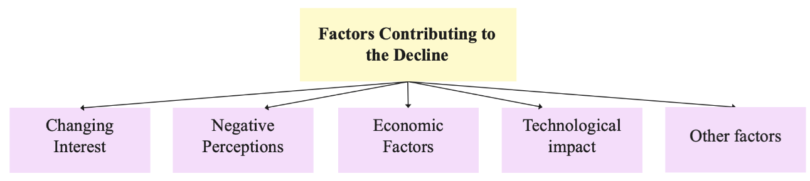

- Change in interest.
- 150-Hour Rule for CPA Certification: This requirement adds an extra year of study, increasing costs and time investment, particularly affecting minority students.
- Negative Perceptions.
- Long Working Hours: Accountants often work more than 40 hours per week, with many experiencing burnout and poor work-life balance. Ex) tax season​
- High Stress and Burnout: The demanding nature of the job and high levels of stress contribute to dissatisfaction in the field.​
- Accounting is often viewed as involving repetitive tasks, such as data entry and routine financial reporting. This perception drives students to choose different fields.​
- Lower Compensation: Salaries for accountants are generally perceived as lower compared to those in sectors like technology and finance, which deters potential candidates.
- Economic Factors.
- Economic Downturns: During economic downturns, companies may cut back on hiring accountants, leading to fewer job opportunities for graduates.​
- Job Security vs. Fulfillment: While accounting offers job security, many professionals leave for more fulfilling and better-paying roles in other sectors like finance, human resources, and business operations.​
- Pandemic Effects: The COVID-19 pandemic has altered career perceptions, with remote work and job market uncertainties influencing enrollment in accounting programs.
- Technological Impact.
- Automation and AI: Emerging technologies like AI are automating many traditional accounting tasks, reducing the demand for entry-level accountants and changing the skill sets required in the profession.
- Other Factors.
- Declining Birth Rates: Lower birth rates mean fewer students entering college, reducing the potential pool of accounting majors.
- Parental Influence and Career Guidance: The advice and influence of parents, teachers, and career counselors play a role in students' choice of major.​
- Media and Public Perception: Negative portrayals of accounting in media and popular culture can deter students from considering the profession.
To address these concerns, I created a graph comparing starting salaries in various professional careers, demonstrating that accounting firms have raised starting salaries to be more competitive. However, it was evident that more efforts are needed to align accounting with other high-demand professions. Furthermore, I developed a summary chart showcasing the benefits that accounting firms are offering to employees, aimed at making accounting jobs more attractive and improving the overall image of the profession.
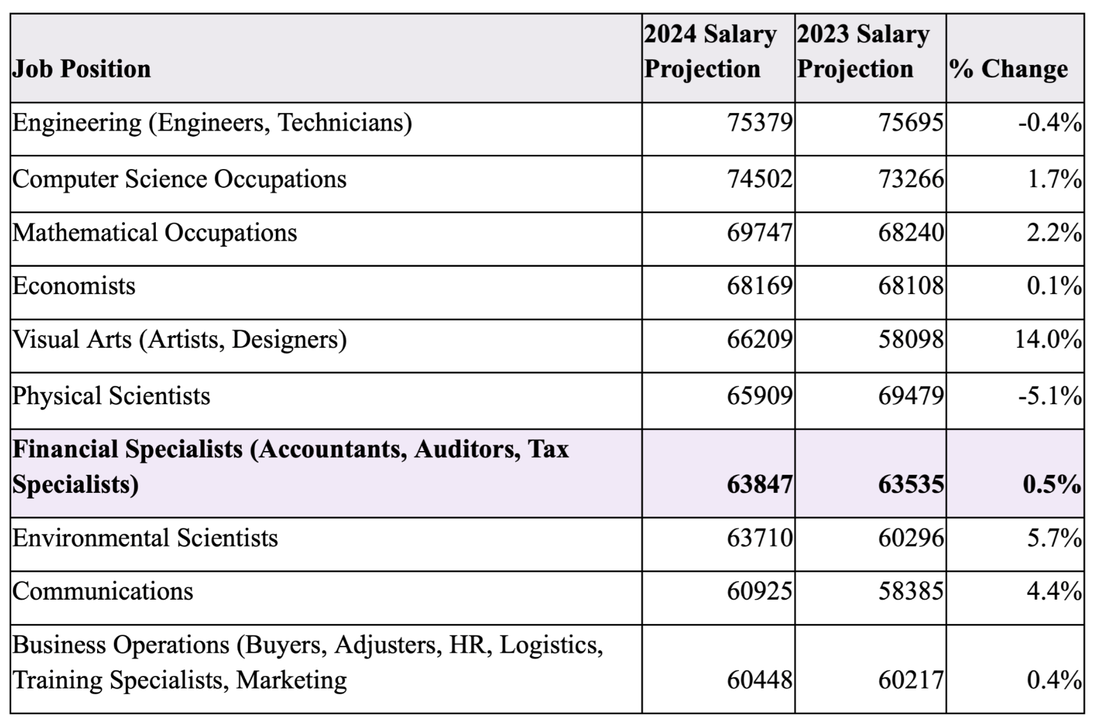
Figure 4. Starting Salary By Academic Major - Bachelor’s. Comparison of 2023 and 2024 Salary Projections for Various Professions. This chart compares salary projections for 2023 and 2024 across multiple professions, highlighting a 0.5% increase in salaries for financial specialists, including accountants, auditors, and tax specialists. Source: National Association of Colleges and Employers
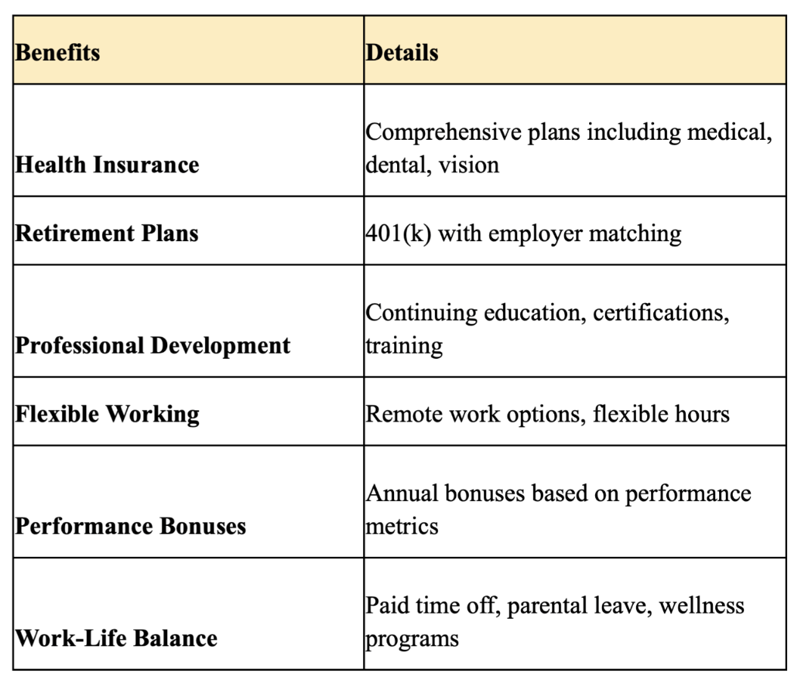
Figure 5. Employee Benefits in Accounting Firms. This chart highlights various benefits offered by accounting firms to attract and retain employees. Source: Data gathered from company websites and industry reports, including Ernst & Young, Deloitte, PwC, and KPMG.

To counteract this declining trend, several strategies have been proposed:​
​
1. Enhancing Curriculum: Updating the accounting curriculum to include courses on emerging technologies, data analytics, and their applications in accounting can make the field more relevant and appealing.​
​
2. Promoting Mentorship Programs: Establishing mentorship programs that connect students with industry professionals can provide guidance and career development opportunities, enhancing accounting careers.​
3. Providing Practical Experience: Offering internships, co-op programs, and other practical experiences can give students a real-world understanding of the profession and its opportunities.​
4. Marketing: Educational institutions and professional organizations need to enhance their marketing efforts to highlight the benefits and opportunities in accounting careers.
This project has been fundamental in shaping my understanding of the challenges facing the accounting profession and the importance of addressing these issues to ensure a steady workforce of qualified professionals. The findings will be invaluable for my future studies at Albion College and beyond. By uncovering the factors contributing to the decline in accounting graduates and proposing effective strategies to counteract this trend, the study provides actionable insights that can be directly applied to enhance Albion's accounting program.
The experience of doing this research has been incredibly rewarding and useful to the accounting field I hope to pursue. I would also like to thank my advisor Connie O’Brien for her invaluable support and guidance throughout this project. I will present my research at the 2024 Mid-Michigan Symposium for Undergraduate Research Experiences (Mid-SURE) and the Elkin R. Isaac Research Symposium in the spring of 2025. Thank you to the Christ Endowment for supporting my research.

