FURSCA End of Summer Report–Zoya Ahmed

Introduction
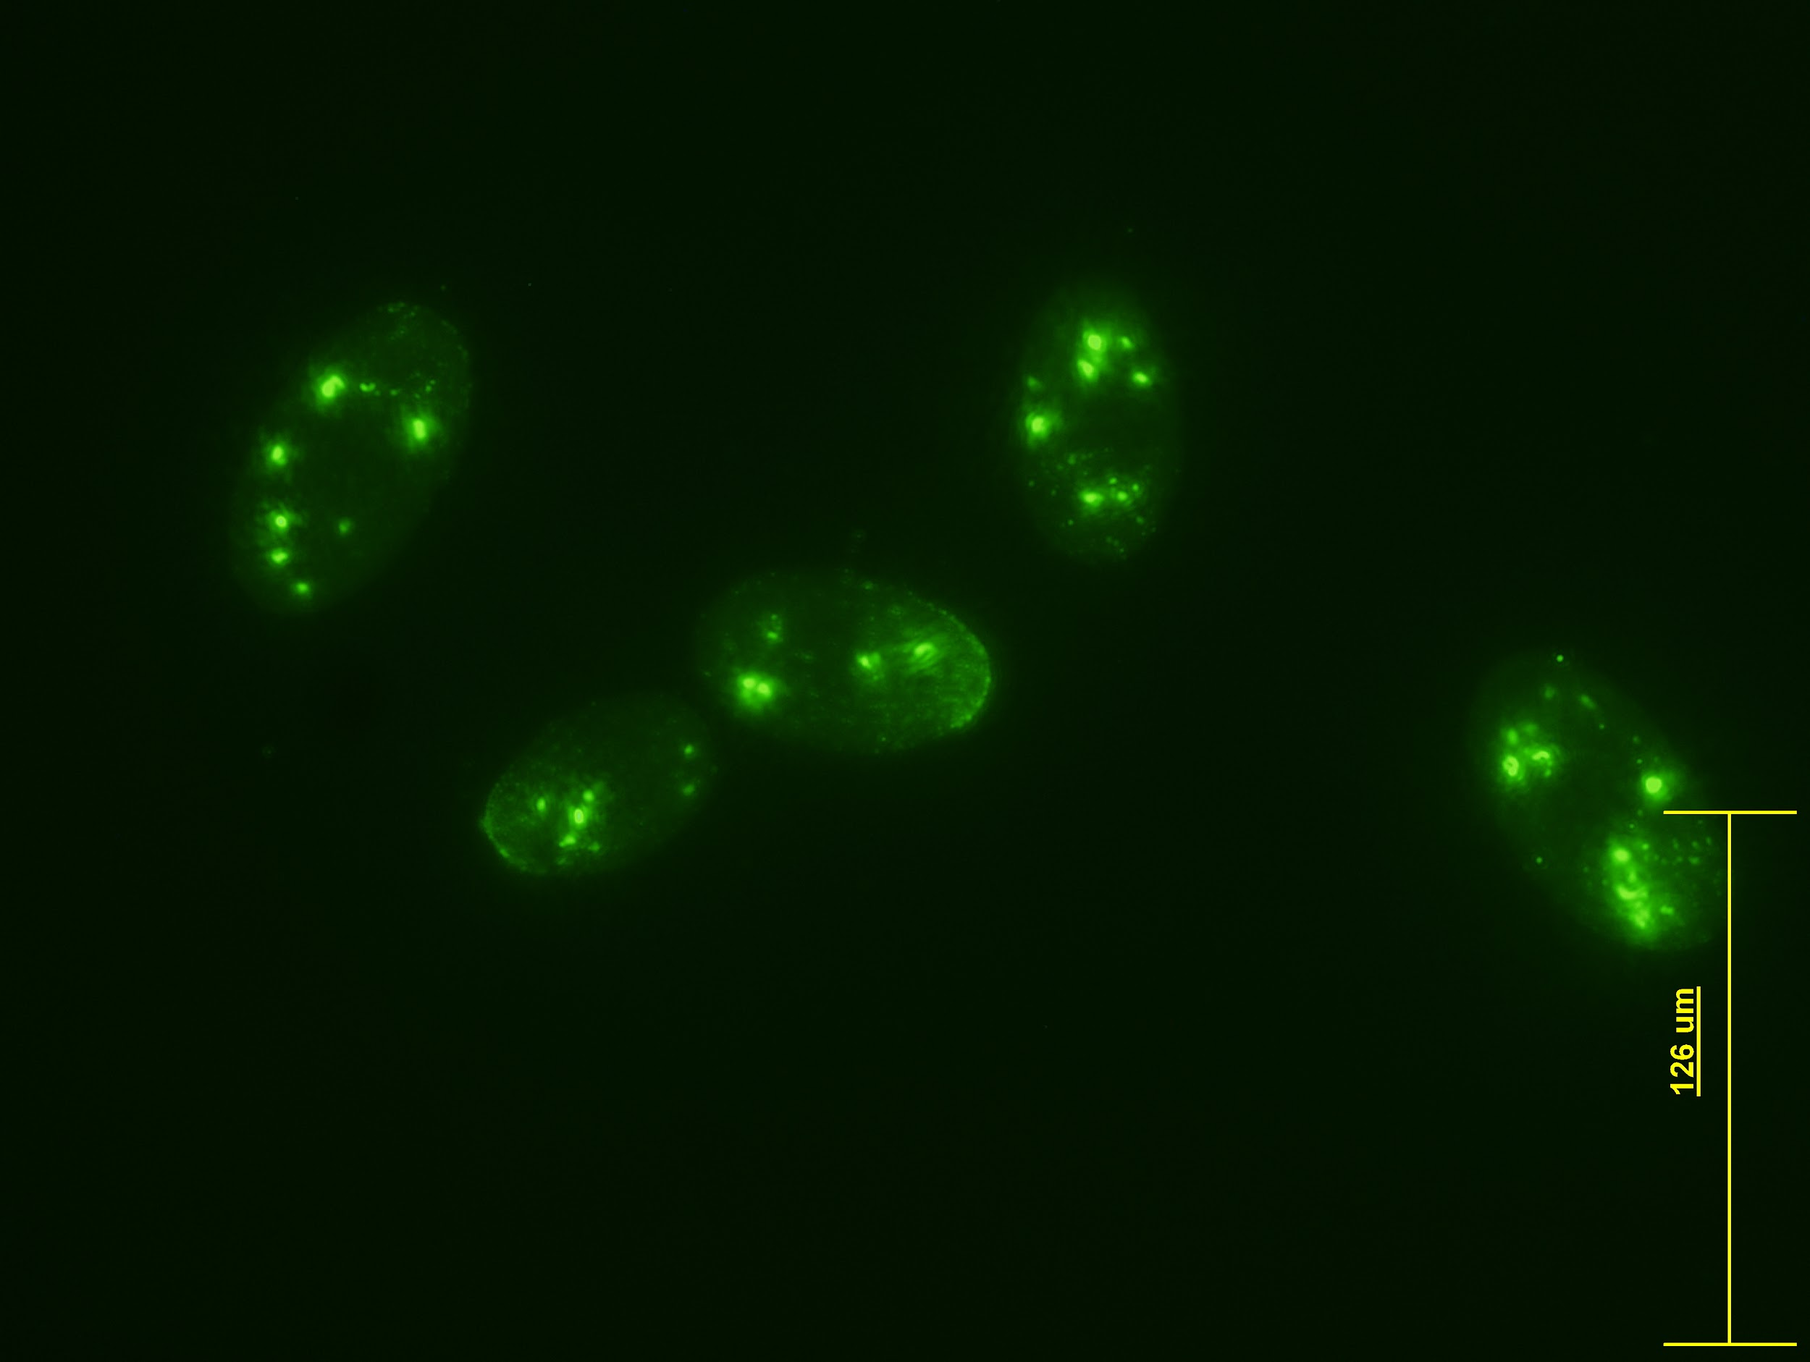
This summer, I conducted a research project investigating protein interactions within Tetrahymena thermophila, an organism commonly found in freshwater. These ciliates are easy to grow in culture and great adapters to the environment, which makes them useful for research study. The broad and overarching theme of my project was gene expression, which is important because the genes expressed by a cell will determine its function. Analyzing the gene expression helps in understanding how those genes are transcribed to make products such as proteins. Throughout the process, genes can be regulated to ensure they function properly, which is important for their development. The specific protein I was studying for the project was Concanavalin A (ConA), a lectin that commonly binds to carbohydrates. When T. thermophila cells recognize cells of a different mating type, it induces a reaction that leads to mating, which is known as co-stimulation. During this process, cells merge together to form a v-shape and gene exchange occurs. In a previous study, Pagliaro and Wolfe (1987) found that the ConA receptor interacts directly with a protein on the surface of the membrane, which is shown by the green dotting on the outer edge of the cell. Adding ConA to T. thermophila inhibits their adhesion and induces association during the mating process. This project aimed to identify the specific protein receptor that the ConA protein binds to on the surface of the cell membrane.

Figure 1. T. thermophila with ConA fluorescence staining.

Results
A common procedure for analyzing protein samples is the Western Blot technique. To extract the protein from the cells, I started out with the cell culture of interest and broke apart the cells to reduce them to a pellet. I prepared a chemical buffer for the cells and after a series of steps, the cells were lysed open to release all the protein. The extra waste of the cell settled down to the bottom and the protein of interest remained in a liquid form at the top, which I then extracted and analyzed. I used polyacrylamide gel electrophoresis to separate the proteins based on their size and charge. My next step was to conduct a blot transfer which would allow me to transfer the protein bands onto a membrane for further analysis. This image would allow me to identify the location of the ConA protein on the gel, which could potentially be sent to a lab for sequencing to discover the specific protein. Throughout the process, I faced a few challenges and had to go back and revise my procedure many times. During the summer, I got through the extraction and electrophoresis process but still need to work on improving techniques for blot transfer.

Conclusions
T. thermophila is a useful model because it engages in many complex processes. This study is important at large because studying protein interactions can help further the field of gene expression and increase understanding of cellular metabolism. I plan to continue this research in the future to achieve successful blot transfers and hopefully identify the transmembrane protein receptor. I plan to share my research findings with the Albion College community at the Elkin Isaac Symposium and the annual Biology Research Symposium and may present at other conferences as well.
I would like to thank FURSCA and the Jane Seymour Kilian Endowed Fellowship for this learning experience. Throughout the summer, I learned a lot both about research and myself. I applied previous concepts I have learned to expand my scientific techniques and skills in the lab. I have also furthered my reasoning and critical thinking skills through frequent troubleshooting. Presenting at the Ciliate Molecular Biology conference allowed me to learn more about the professional scientific community, which gave me more inspiration and confidence for further pursuing scientific research. It was a rewarding experience overall, and I am grateful for the opportunities that the FURSCA committee and the donors have provided me with.

