End of Summer Report 2020
Introduction
My 2020 FURSCA project was a continuation of my 2019 FURSCA and 2019-2020 school year project in which I worked with Dr. McCaffrey on the Microwave-assisted Duff Reaction. Conventionally, the Duff reaction has long reaction times and gives very low yields. Through the last year of study, the use of a microwave reactor has proven to significantly reduce reaction times while maintaining or improving yields of the Duff reaction with methyl-, methoxy-, and nitrophenols. The goal of my project this summer was to complete an in-depth analysis of the data I have collected over the past year and organize these results that will be used in my thesis. The primary method of product analysis was by gas chromatography/mass spectroscopy (GC/MS). Nuclear Magnetic Resonance (NMR) was taken for most reactions, but many were very complex due to overlapping peaks, making an accurate interpretation of the spectra very challenging. I have been using the program Mnova by Mestrelab to view and analyze the chromatograms and spectra, as well as label and stack spectra for comparisons.

Results
Over the summer, I was able to analyze all the data I have collected from this project which took four of my nine weeks. I am still communicating with customer support about a few questions relating to the programs GC/MS peak detection, but I was able to confidently characterize all but six peaks that appeared in the various chromatograms. Through this analysis experience, I thought of a few more reactions to make our project more thorough and completed most of the analysis needed for the results and discussion section of my thesis.

For the remaining five weeks, I worked on the outline of my thesis, drafted and finalized my methods section, and started the first draft of my results section. One aspect of the results section is discussing the effect of changing specific variables on the yield of the reaction. With Mnova, I can stack chromatograms to visually compare the outcome of different reactions. For example, Figure 1 shows the chromatograms of the reaction of para-methoxyphenol (pOMe) with 4 M HCl hydrolysis and 6 M HCl hydrolysis. Creating stacked chromatograms/spectra to compare the effects of time, temperature, hydrolysis length, and hydrolysis strength was an additional task that I worked on before writing my thesis.
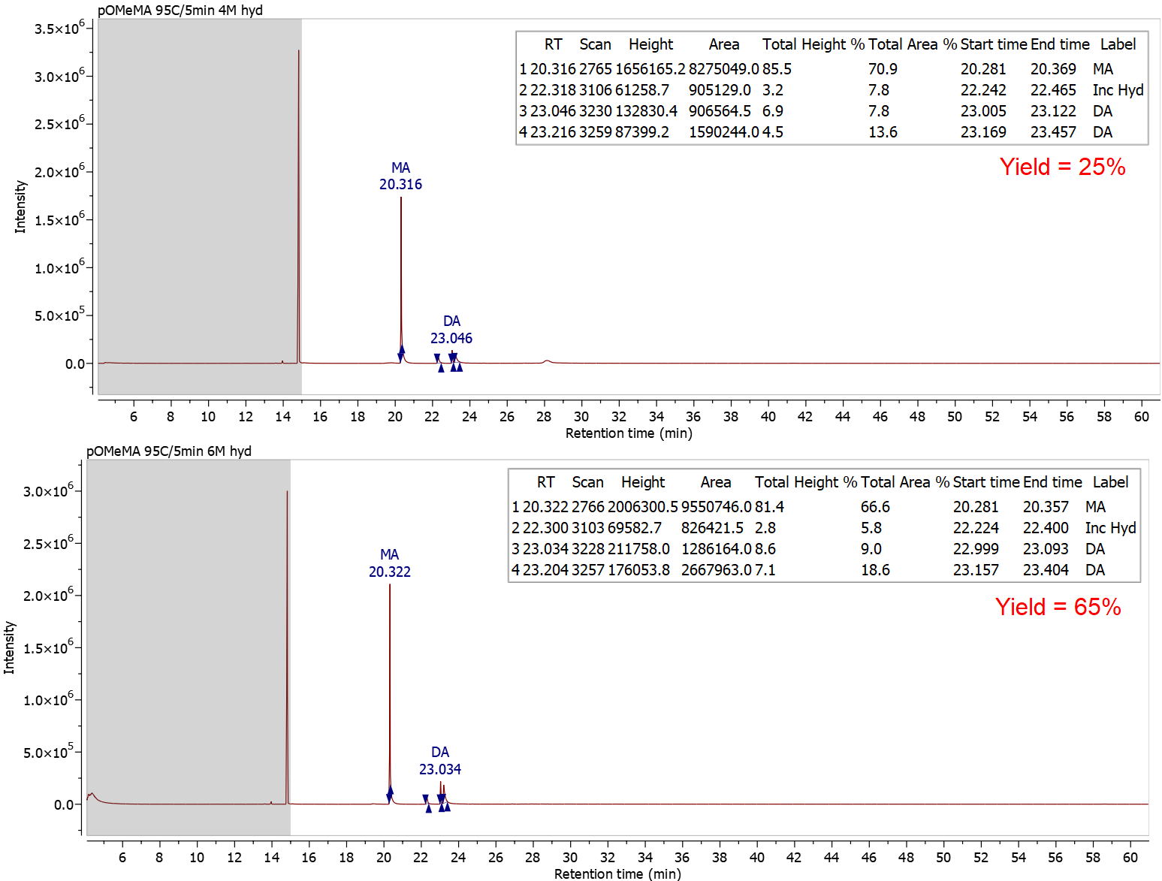
Figure 1. Stacked chromatograms of pOMeMA 95 °C/5 min 4 M hydrolysis (top),
6 M hydrolysis (bottom). Labels: monoaldehyde (MA), dialdehyde (DA), incomplete
hydrolysis (Inc Hyd).

Last summer, a dimerization reaction with the methyl phenol Duff reaction occurred, and while a proposed structure was found that agrees with the MS data, a mechanism was not proposed. This summer, San Pham spent some time working on a promising mechanism based on the novolac studies of David H. Solomon and Xiaoqing Zhang (Figure 2). Her contributions are greatly appreciated. Additionally, structures of incomplete hydrolysis products were proposed based on research published by I. S. Belostotskaya, et. al. (Figure 3) which holds resemblance to the dimer. The proposed mechanism and structures help my thesis to be more thorough, as the dimer and incomplete hydrolysis peaks were very common peaks in the study of methyl- and methoxyphenols.
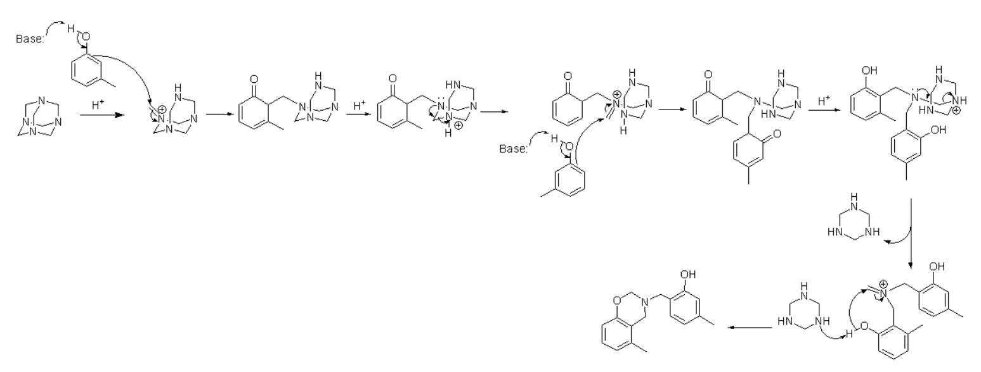
Figure 2. Proposed dimer mechanism by San Pham based on mechanism from novolac paper (Solomon, D. H.; Zhang, X. Polymer. 1998. 39, 6153–6162.)

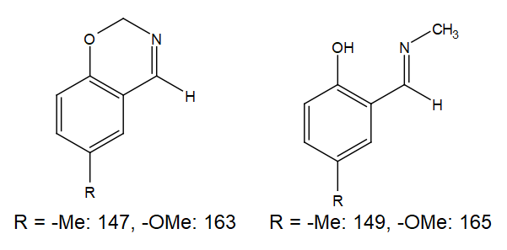
Figure 3. Proposed structures of incomplete hydrolysis products with corresponding masses based on structures from Belostotskaya, I. S.; Komissarova, N. L.; Prokof’eva,
T. I.; Kurkovskaya, L. N.; Vol’eva, V. B. Russian Journal of Organic Chemistry. 2005. 41, 703-706.

Conclusions
While last summer gave me a glimpse at the laboratory research side of graduate school and a career as a chemist, this summer gave me a glimpse of the out-of-lab experiences of data analysis and scientific writing. Both summer experiences helped me realize graduate school was something I was interested in and will help me there in the future. This experience helped me to grow and become more confident as a researcher. Though I couldn’t be in the lab, I was able to learn a new program, improve my literary research skills, improve my scientific writing skills, and start my thesis, which will reduce a lot of stress during the school year.
FURSCA has given me, and many others, the opportunity to participate in research projects during the summer and get paid while doing it. This foundation allows students to spend the summer working on projects that they are passionate about, and a significant reason it has been able to do so much for students like me is because of donors. My project was supported by the Anna and Carl Weiskittel Endowed Chemistry Fellowship which allowed me to purchase a vital program for my data analysis and more reagents to study in the fall. I would like to thank Anna and Carl Weiskittel for their generosity and support towards this program and my project. I plan to attend graduate school and become a professor at a small liberal arts college like Albion (well ideally at Albion, but I think our chemistry faculty are here to stay for the foreseeable future). The research your fellowship funded has helped me confirm my love of research and will help in my admission to graduate school.

This past spring, I was not able to present my research at the 2020 ACS National Meeting or at Elkin Isaac as previously planned, so I hope I will be able to participate in both during the spring of 2021. I plan to present a poster at the ACS National Meeting and a PowerPoint presentation for Elkin Isaac.

