Name of student researcher: Marcelle Poleto Collares
Graduation Year: 2023 Major: Geological Sciences
Research Advisor: Suellyn Henke Advisor’s Department: Education

Title of Project: Enhancing Water Literacy for Teenagers Using the Ludic Method

My project was focused on how to teach and apply the ludic (also known as playful) method of education. During the last 10 weeks, I have been reading important books and articles about this method and planning a way to apply it to a Social Studies 6th-grade class at Mar Lee Middle School taught by Professor Chris Henke. I have also watched movies and shows in which this method was used, and had structured conversations with educators.
My goals were to understand the ludic method of education and the reasons to apply this method instead of the traditional one, write a rationale to explain the ludic method and how it can be implemented, develop a curriculum project for the social studies class in Mar Lee Middle School (Marshall, MI) about water to be implemented during the fall/spring semester (depending on COVID-19 restrictions) and to present my research in an Education Class at Albion College next Fall.
My results consisted of the development of 5 classes. Some of the topics that will be taught are the importance of learning about water, water pollution (focusing on the 2010 Enbridge Oil Spill in the Kalamazoo Watershed), and water-related terms. Sample analysis and debates have been planned to happen.

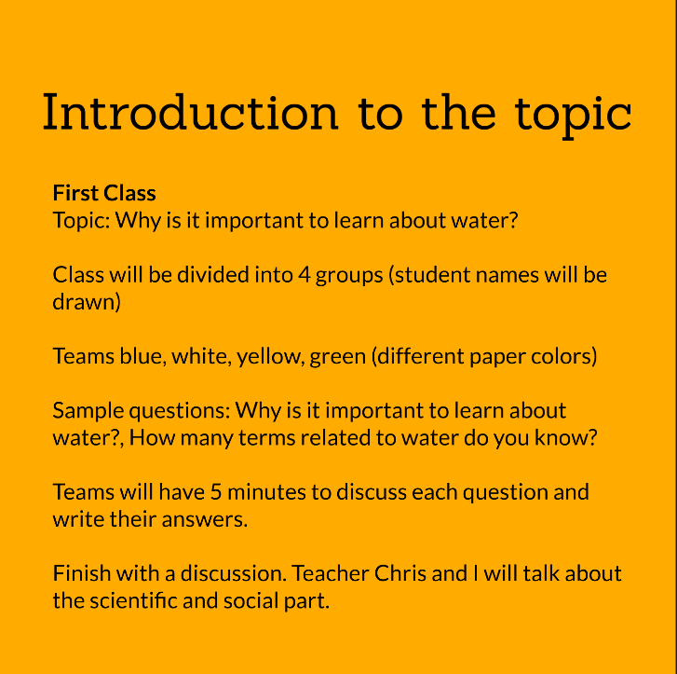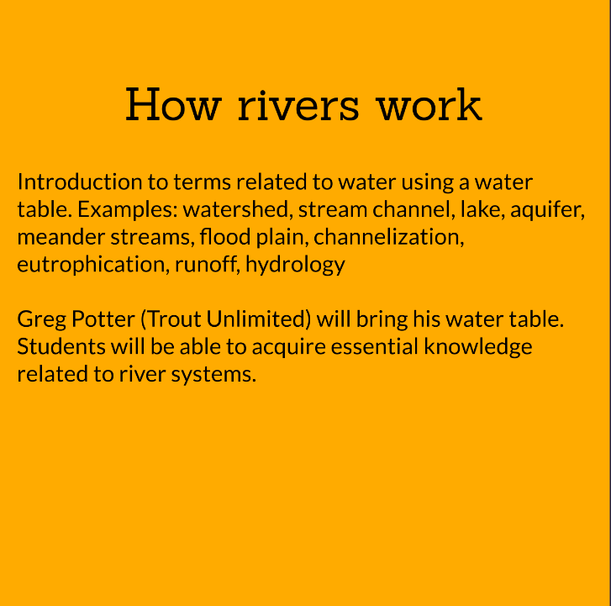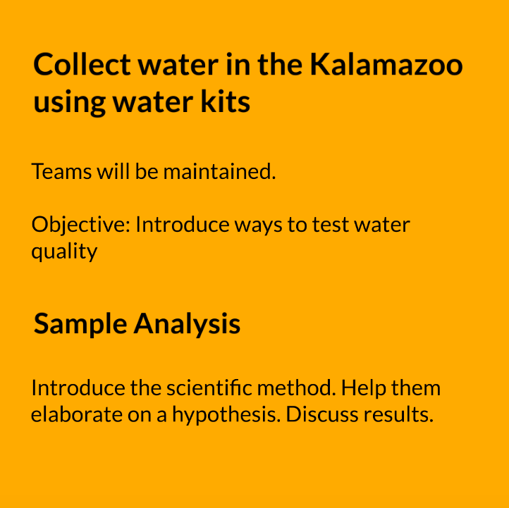
Figures 1,2, and 3: initial drafts.

I had achieved my goals even though I could not meet with the students during the FURSCA program as I was planning on doing. The fact that I could not go to Mar Lee Middle School because of the COVID-19 Pandemic had made me change my plans: instead of watching classes and trying to understand the best way to deal with the students, I had structured conversations with educators that helped me shape my outcomes.
My project helped me become a better educator. When I graduate, I want to develop ways to make access to scientific education easier. Learning about planning classes taught me how flexible educators should be to better accommodate all students with all kinds of needs. I also learned that changing my plans can be wonderful since they had to be changed due to COVID-19. I plan to disseminate the knowledge I got from this research at the Elkin Isaac Symposium and at the Incoming International Students training which will happen next Fall.
I would like to thank Jean Bengel Laughlin, '50 and Sheldon Laughlin Endowment for Student Research for making it possible. As an international student from Brasil, this opportunity felt like one more step to becoming the person and professional I want to be in the future. I am immensely grateful for their support and for changing my life, and I would be happy to get to meet them in person to talk about my research and express my gratitude.

