End of Summer Report of Summer FURSCA 2020
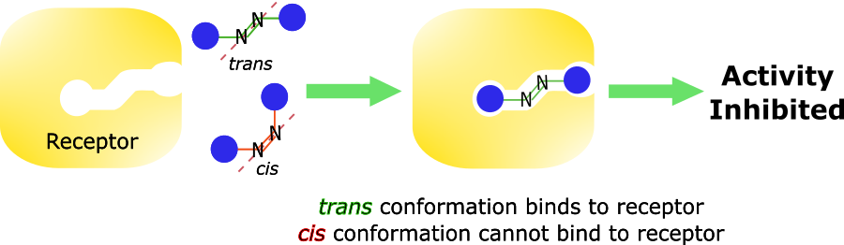
Figure 1. Mechanism of action of azo drugs (created by me)
This summer is my second time doing Summer FURSCA, and the experience this time was surely interesting. However, when I proposed my project with the expectation of a normal summer with Dr. Craig Streu, we were planning on starting out a totally different research than what I did last summer. For this summer, I was expecting to work on growing nanobodies (a fragment of a typical antibody) on yeast cell surfaces so I could do artificial selection (or directed evolution) to pick out nanobodies for desired functions, specifically to inhibit the assembly of type III secretion systems responsible for gram-negative bacteria’s mechanism of infection. However, when COVID19 wreaked havoc on everyone’s life, my research project had to be adapted for the online format as growing nanobodies is impossible without a laboratory. Thus, my project changed to continuing my last summer’s project because some aspects of it could be done virtually. To summarize my previous research, I have been working on adapting light-switchability to published cancer drugs with the intention of creating controllable and specific cancer therapy that could minimize side effects that usually occur in normal chemotherapy and radiation therapy. In order to do this, I had to utilize azo bond (nitrogen-nitrogen double bond) which has the ability to switch shape from trans to cis, and vice versa. Trans and cis are two shapes of a molecule, but they have different activity on cancer targets, which are usually proteins that control important functions in cells such as cell growth. As shown in figure 1, cancer drugs work in a lock-and-key manner, so if we have the ability to control their shapes, we also have the ability to control the drugs’ activity. Last summer, I was able to synthesize my azo molecule (Figure 2) which acts on a protein responsible for uncontrolled cell growth when mutated called c-Kit. I also measured its photokinetics activity which shows how it could change shape with certain light wavelengths. This summer, my goals were to continue this project by doing computational simulations of the drug’s binding activity on the crystal structure of c-Kit, as well as working on a testing system for the drug to test its activity on live cancer cells. Besides this, I also read multiple journal articles to better my understanding of my nanobody research and created original figures via Inkscape for future presentations and talks.
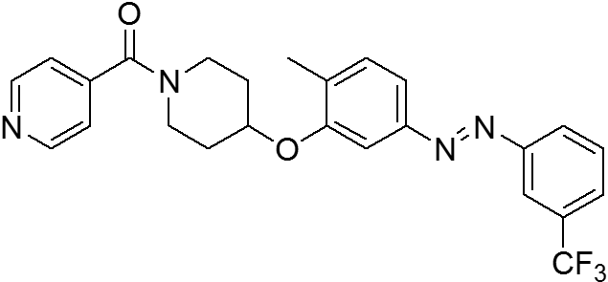
Figure 2. Azo c-Kit inhibitor
For the first part of my project, which is the computational analysis, I was able to use a program called Chimera to simulate the binding of azo c-Kit inhibitor into the crystal structure of c-Kit. I discovered that the drug fits well into the binding pocket of the protein in the trans conformation. Next, to make sure that there would be marked difference in binding between trans and cis conformations of the drug, I did a docking simulation of the cis form of the drug, and as expected, it could not fit in the pocket at all (Figure 3). This helped us predict that we would have the desired outcome when testing on live systems.

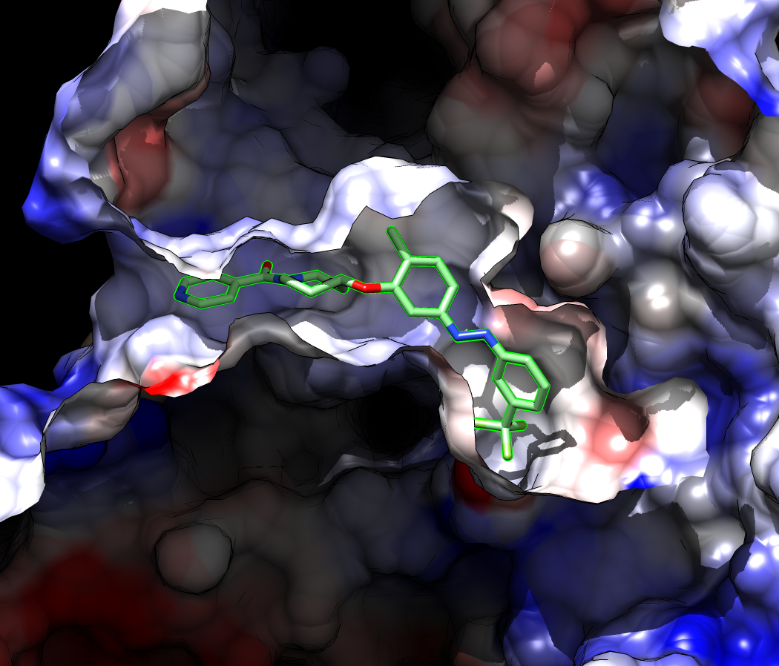 | 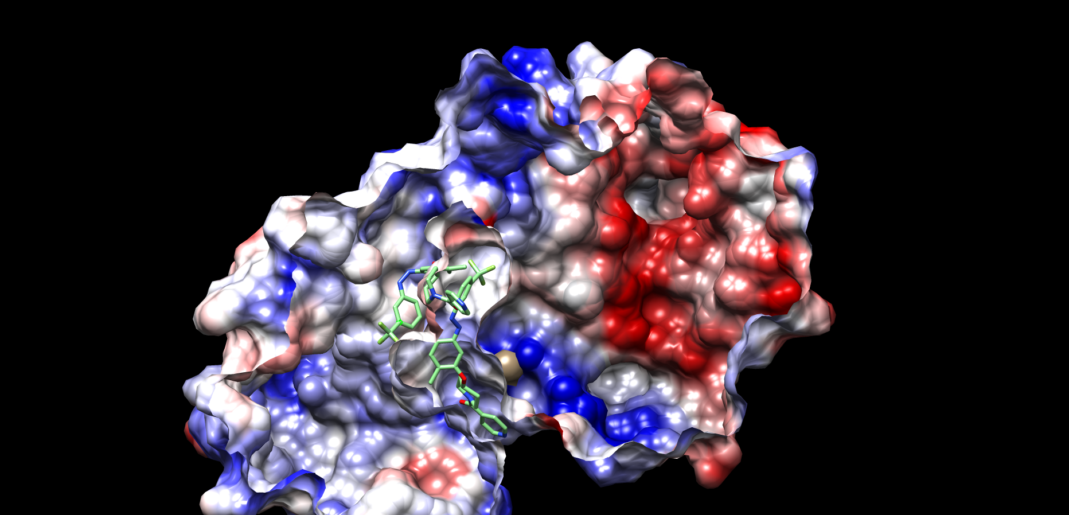
Figure 3. Computational simulation of azo c-Kit inhibitor in c-Kit on Chimera. Trans conformation (left) fits in the binding pocket, while cis conformation, which does not fit into the binding pocket (right) is circled in red
For the next part of my project, I designed a testing scheme to test azo c-Kit inhibitor on live cancer cells. As shown in figure 4, the first step of my scheme is to grow cancer cells on petri dishes. From past information, the drug is shown to exist predominantly and be active in trans conformation, we would have to shine UV light to inactivate it by switching it to the cis conformation. From there, we could plate it on the cell culture. At this point, we expected to see no effect on the cells. Then, we would have to use computer programs to control the light: with UV light, the drug is inactive, and cells survive; with red light, the drug turns to trans conformation and is active, which in turn should kill the cancer cells. The reason computer programming is required is because the testing will be spanned out for days so we could test if the drug is applicable for use on patients over a long period of time with as few doses as possible. In order to do this, I have been learning the Python programming language in order to understand basic codes. Then, since researchers have published procedure and computer code for this light relay system, I worked on modifying the code to make it suitable for our purpose. Over the summer, we have also purchased electronic parts to create the lighting system and have been working on creating the light system. This project will be continued in the fall or as early as when it is possible to come back to the lab.
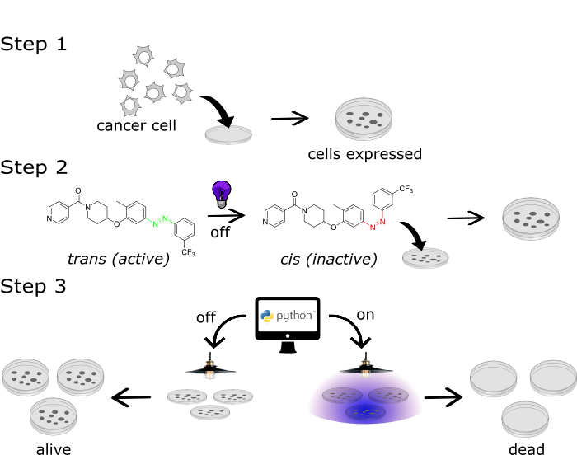
Figure 4. Testing scheme of azo c-Kit inhibitor on live cancer cells (created by me)
Working on the continuation of my summer project has helped me broaden my skills and knowledge. As a upcoming senior, I have to plan for the future after my graduation, and these experiences have helped me to decide to further my studying and research by going to graduate school. Last summer, I was still contemplating between MD/PhD and PhD only program, but I have made up my mind to forgo the medical school because I feel that having a PhD and doing basic science research can help guide the medical field to more advanced treatments and therapies. I also have gained considerable amounts of skills that make me more suitable for the ever-changing job market and could help me stand out from other graduate school applicants. I have no word to describe my appreciation for the opportunity that FURSCA has provided me. Without this experience, I might have not known the joy and thrill of doing research. It also shaped my career goal as I want to work for the pharmaceutical industry on their efforts to create better drugs. If everything goes well with COVID19, I plan to present my research at Elkin Isaac Symposium and at the American Chemical Society Conference in the spring of 2021. I also plan to write a departmental thesis on my current project.
I would like to thank the Richard K. Vitek, '56 FURSCA Endowment for funding my research and providing me with the opportunity to explore the subject I am interested in as well as exploring my career options. This experience has enabled me to gain skills that could never be taught in a normal classroom environment. I will keep working hard so not to waste this opportunity given to me. Once again, thank you very much for investing in giving undergraduate students opportunities to do research.

