Dear Bethune Fellows Student Research Endowment,

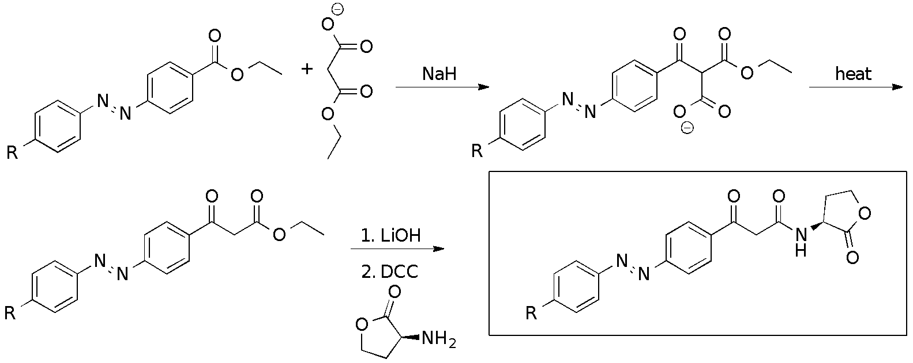
Figure 1. First synthesis of a Beta-Keto Amide Acyl-Homoserine Lactone.
This summer I worked on the synthesis and evaluation of photo switchable quorum sensing signaling molecules. Quorum sensing is that cell to cell communication used in bacteria. The signaling molecule diffuses into the bacteria cell and binds to the transcription factor, thus starting gene expression. I am focusing primarily on gram negative bacteria that use Acyl-Homoserine Lactones, or AHL, as their signaling molecule. My main goal is to take these AHLs and add an azo bond to make it photo switchable, and by doing this, we would be able to turn gene expression both on and off.
Figure 2. The improved synthesis of the Beta-Keto Amide Acyl-Homoserine Lactone.
I was able to make it almost all the way through my chemical synthesis for my beta-keto amide AHL (figure 1). I had quite a few bumps along the way, as some of our solvents like THF were not as dry as they should have been, so we had to think of new reactants for the different steps of the synthesis. When I ran the first reaction which is a Malonate addition to ester, we were getting very low yields due to the fact that our THF was not dry, so the water was causing the ester to hydrolyze. We had some product that added the Malonate, and hydrolyzed, taking us to the lactone coupling reaction, but unfortunately it was not enough to move forward.
After trying different techniques to try to get the malonate addition to produce a better yield, we decided to try a new reaction. We came up with a new synthesis to try to produce better results (figure 2). We decided to do a Claisen condensation using Potassium tert-butoxide and THF. At this point we still didn’t know that our THF wasn’t dry, but we did get better results for this reaction, so once we try it with the brand new THF, I believe the yield will increase even more, especially since the paper we found this reaction is claims a 99% yield. Once we did that reaction, we moved on to a base hydrolysis reaction using the LiOH. Unfortunately, instead of preforming a hydrolysis of the ester, it reacted with the alpha carbon since those hydrogens are acidic, thus reversing everything we had done in the previous reaction. We performed an acid hydrolysis instead, which did produce the intended product. I am currently at the lactone coupling reaction, which I have already done with a previous completed synthesis, so we hope that it will work with our double carbonyl as well.
I was able to successfully finish the first two steps of my synthesis. Unfortunately, the Malonate addition to the ester was what caused me a lot of trouble, since the THF wasn’t dry. I believe that if the THF would have been dry, we would have finished the synthesis this summer.
If I am able to finish this project, and run biological testing, this could help the world of engineered bacteria. This will allow gene expression to be turned on and off. This could lead to things like controlled CO₂ reduction or plastic eating bacteria. This project was very interesting, and I was able to improve my lab skills for both chemistry and microbiology. I plan to go into the medical field, and since engineered bacteria has already been used for that field, maybe this could help improve it one day. This project has helped me really learn patience, especially when things do not work out like you planned and helped with my problem-solving skills. When my project was not resulting in high yields, I had to sit down with Dr. Streu and figure out why and plan a new strategy. In the future, I plan to use this research to write my thesis, as well as present my findings at Elkin Isaac and the ACS conference in Philadelphia 2020.
I would like to give a huge thank you to the Bethune Fellows Research Endowment for funding this project this summer. It was a lot of fun, and I not only improved my lab techniques but was also able to increase my knowledge in the area of quorum sensing bacteria.

Thanks,
Shelby Stajdl

