FURSCA End of Summer Report
Summer 2019

Noah Robertson
Albion College

To begin, I feel as if many thanks are in order. Without the hard work, enthusiasm, and generosity of these individuals, my summer would not have been nearly as productive as it was.
Firstly, I would like to thank Dr. Craig Streu for being the best research mentor I could have asked for. I have been working with Dr. Streu since fall of my freshman year, but it was after a summer of research in Chicago with Dr. Lawrence Schook ‘72 that I started this project. Inspired by the research I was a part of, I came to Dr. Streu with an idea, and without any qualms he took a chance and said yes, leading me to where I am right now.
Secondly, I would like to thank those who are involved with FURSCA. Dr. McCaffrey and Renee Kreger did an excellent job of organizing this summer for all of us student researchers to take a closer look at topics they are passionate about as well as gain experience that can position us for future success.
Furthermore, a special thanks to the Lawrence B., '72 and Frances Schook Research Fund in FURSCA for supporting my project. The generous financial support has allowed me to purchase the chemical building blocks we need to try to synthesize our target molecule and learn more about chemistry along the way. The continued support from these two is something I am especially grateful for because from that summer on, they have challenged me to keep learning, exploring, and improving the work and research I do.
Lastly, a big thank you to Dave Carey – the man who was always in the lab earlier than us. Without him, the amount of success from the labs would be cut in half because he puts in many hours to make sure that we have all that we need and that our lab is a safe environment to work in.

Introduction
Summer 2018, I had the opportunity to learn a lot about cancer, namely genetics and types of cancer treatments. One of the treatments that stuck out to me was immunotherapy, with the use of immune checkpoint inhibitors. An immune checkpoint regulates our immune system, so we can think of a checkpoint inhibitor as a brake pedal or a gas pedal on our immune system.
However, I was also thinking about my research with Dr. Streu, which involves the synthesis of azo molecules as potentially effective photodynamic therapies. This is because azo molecules, which contain a nitrogen-nitrogen double bond usually between two aromatic rings, can change their shape back-and-forth from cis to trans conformations with light.
I wondered if I could combine both of my research experiences, so I googled “PD-1 inhibitors.” All of these drugs were big proteins, so we could not make azo versions of that. Then, I searched for “small molecule PD-1 inhibitors,” and found a plethora of molecules currently being made by Bristol-Myers Squibb that had a carbon-oxygen single bond between two aromatic rings. When I brought this to Dr. Streu, he said we could definitely change that C-O to a N=N bond.
We hypothesize that if we synthesize the molecule below, we would have a drug that would act as a gas pedal for our immune system that we can activate in certain areas of the body with light. By changing the drug’s shape, we believe it could prevent the PD-1/PD-L1 connection that cancer has highjacked to evade our immune system in one part of the body, while being harmless everywhere else due to its inactive shape.

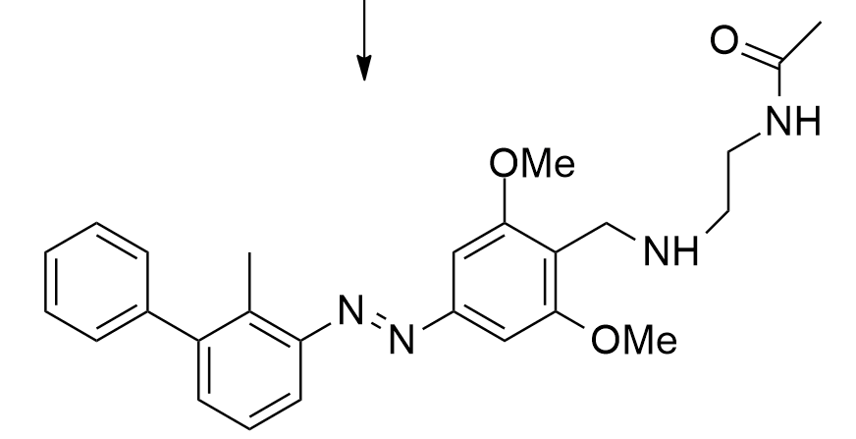

Summer Progress
Altogether, the synthesis part of my project involves a seven-step synthetic route, which we started the summer on the 4th step. In the 8 weeks of research, we were able to refine the conditions for the first four steps in the process to obtain better yields.
We also determined that by changing a halide on our molecule from a bromine to iodine, we can cut out the original 4th step and obtain an intermediate that should be more reactive. This will in turn give us a better yield because there are fewer steps to lose product on. A large part of our research was trying to narrow down conditions of this new Sandmeyer reaction because it is something new to us and has never been done on a molecule similar to mine. We are 100% certain that we synthesized this new intermediate based on NMR spectroscopy and mass spec.
Lastly, I was able to perform computational modeling of our molecule and how it fits into its target. We did this by using the same protein model that BMS used, and with Chimera and AutoDock we docked our azologue into the same binding site (see image below). The docking score for our molecule was a -10, which indicates that the molecule has an excellent fit in the active site when it is in its trans conformation.

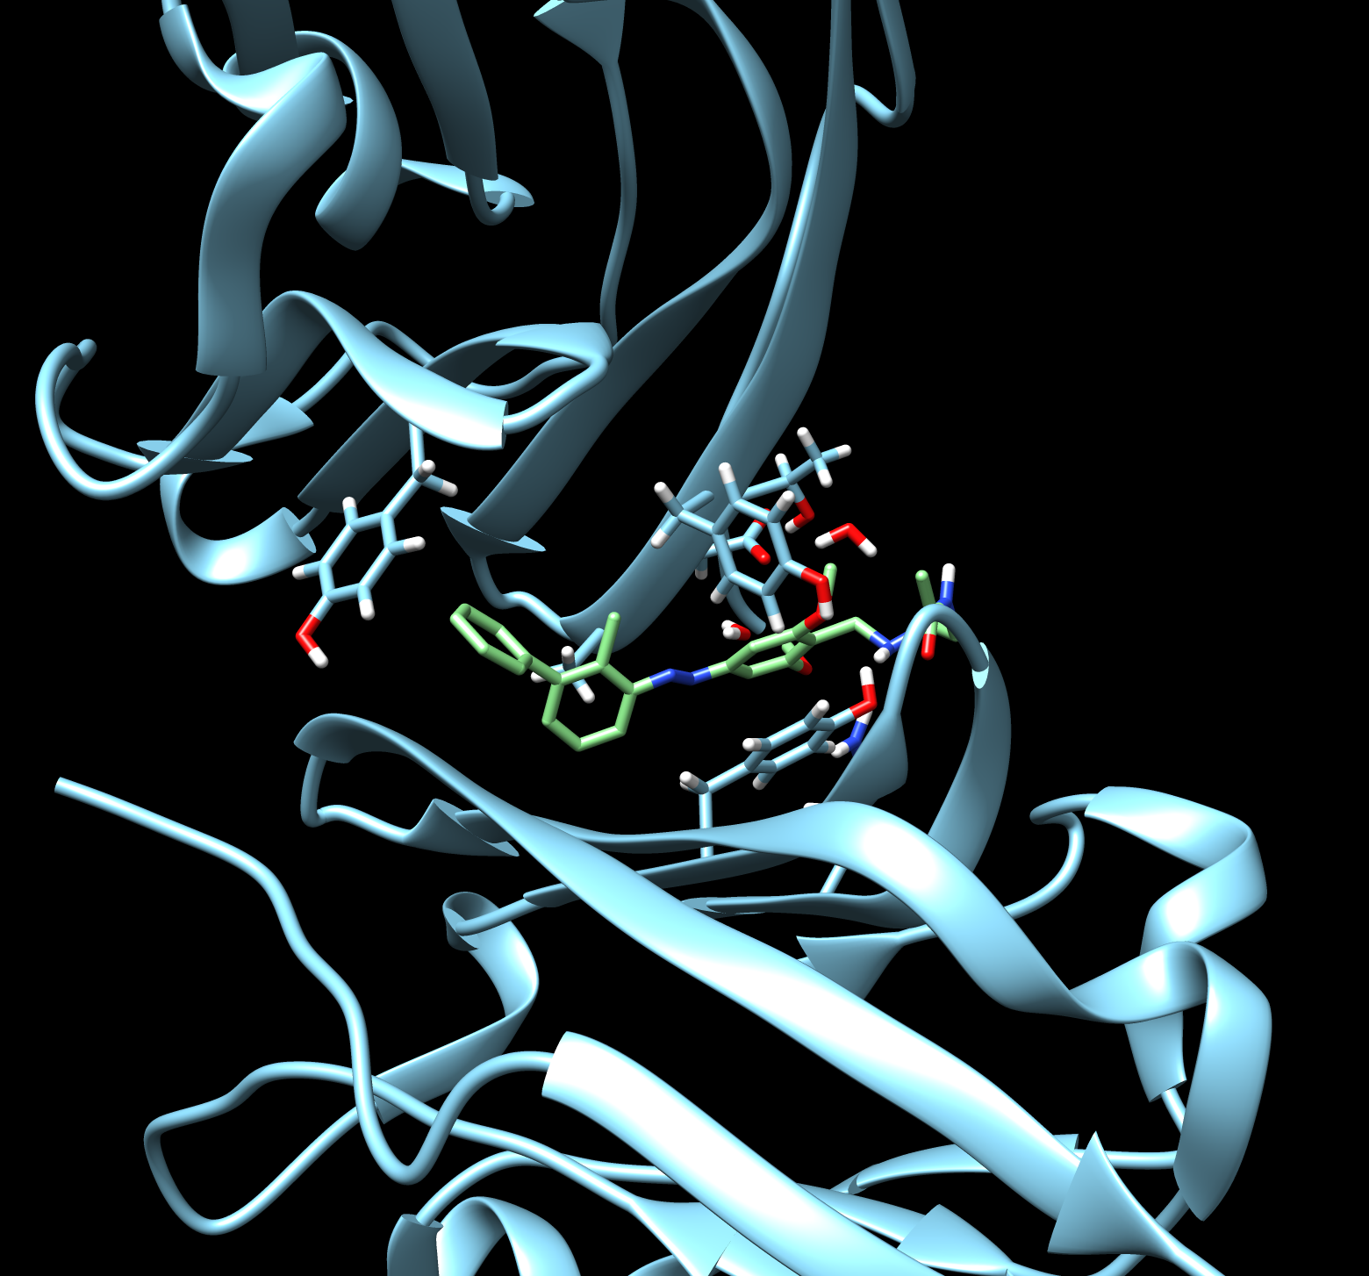
Future Work
Throughout the upcoming academic year, I plan to keep running reactions until we find a way to convert the iodine into an aldehyde via a formylation reaction. There are many procedures with steric hindrance near similar to ours, so I have high hopes that we can eventually have a successful 5th step. Once we have that aldehyde, we can add the final amine side chain via reductive amination, which is a reaction that typically has very high yield and is easy.
Once we synthesize our goal molecule, our next steps will be to test its ability to photo-isomerize, and then we will have to tap into our creativity and find a way to test the molecule biologically.
Overall, this summer was a very special experience for me because I learned a lot more about the real world of chemistry research in the lab, I had the opportunity to practice lab techniques, continue learning about organic chemistry, and do fun work with some amazing people.

