Tess Rennalls
FURSCA
Summer 2021
End-of-Summer Report 2021
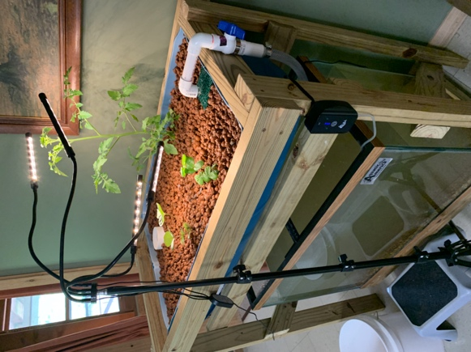
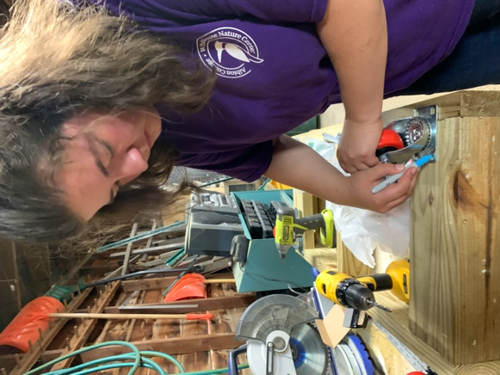
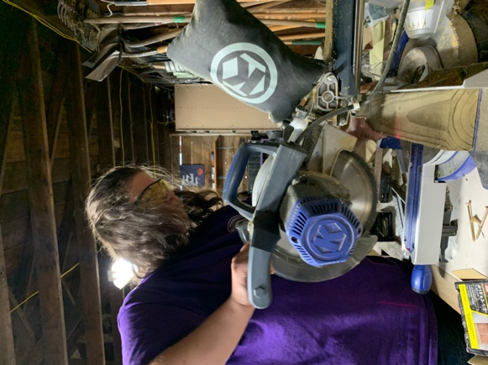
This project aimed to compare student engagement of elementary children in different instructional settings while teaching about aquaponics and all its facets. This summer, I created and worked on an aquaponics system that exemplified sustainable agriculture, chemistry, biology, and botany concepts. This goal was designed to explore the application of large-scale science projects in the elementary classroom. Experience with teaching and developing lessons that center science concepts is essential as an elementary education prospective teacher. Over the course of the project, I hoped to improve my teaching methods by analyzing student engagement.
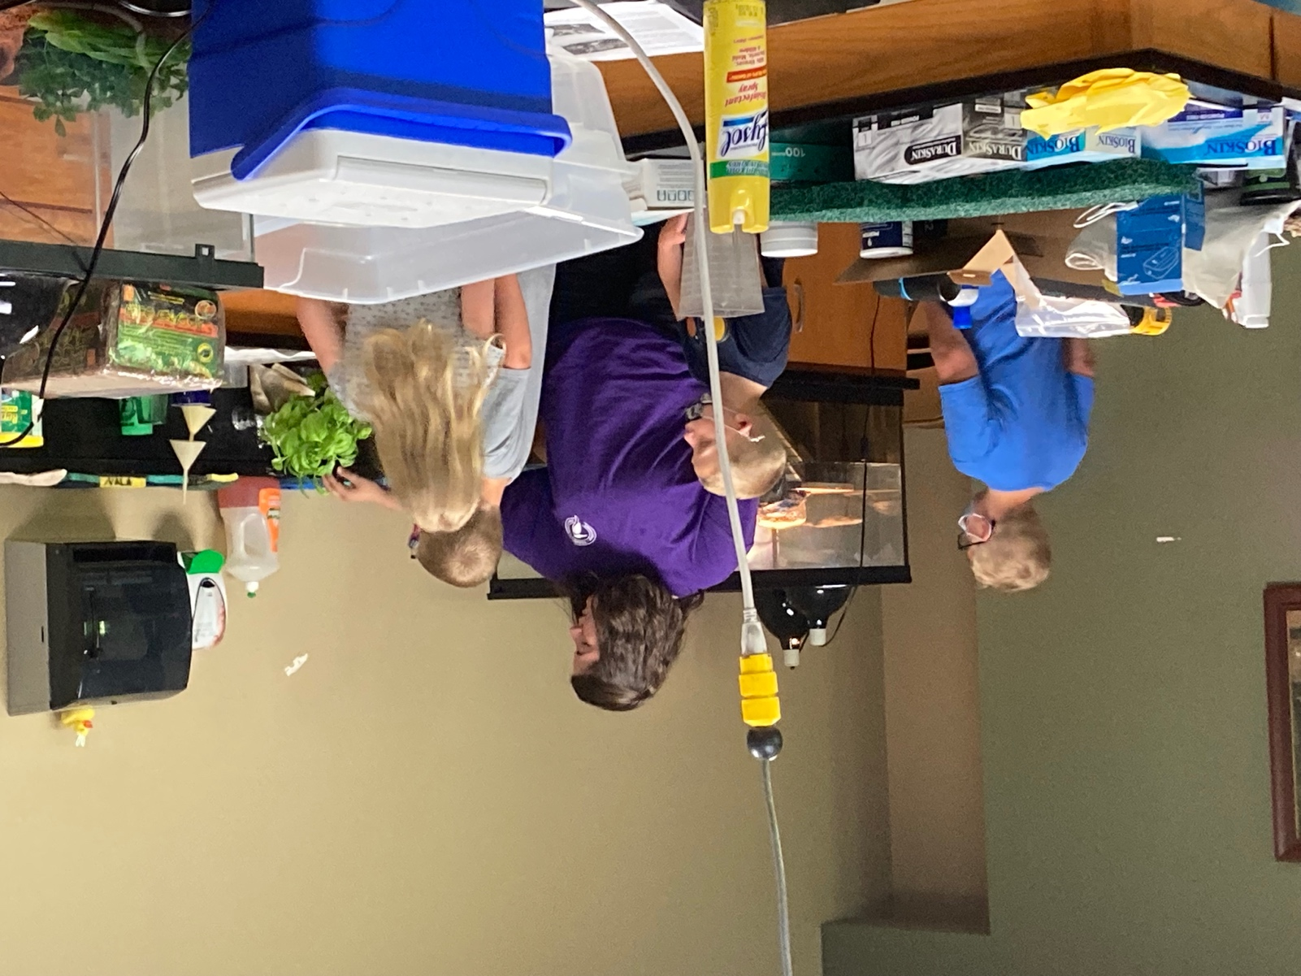
To start my project, I built an aquaponics system using a 55-gallon food-grade barrel. I originally planned to have a continuous flow system, but I wanted to challenge myself with a bell-siphon as the project went on. In a continuous flow system, the water is at a constant level and is continuously flowing out of the standpipe. A bell-siphon creates a suction so the grow bed can fill and dump, creating a complete cycle. This is helpful for plants that do not like being submerged in water. This method took a lot of tinkering with resistance, timing, and water flow. However, working through the many iterations of the system and cycling the tank gave me valuable experience outside of my major.

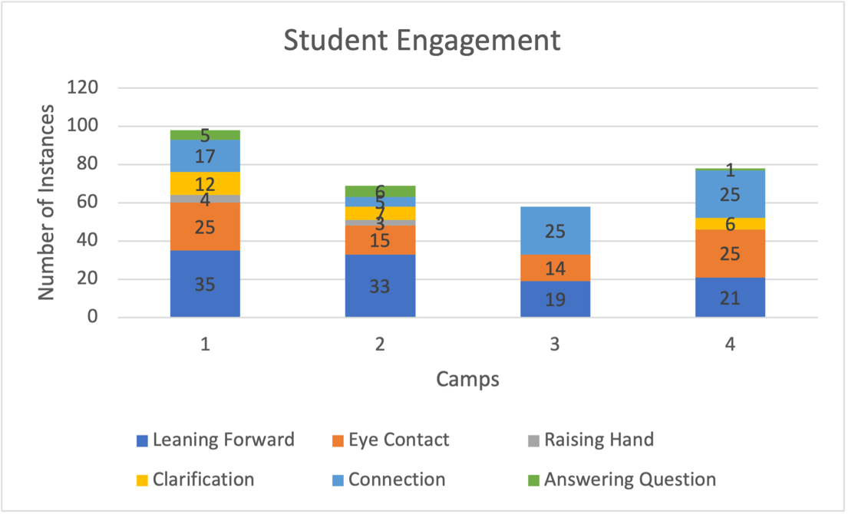
I was able to create a 5-day unit plan for elementary students. This unit plan is aligned with Michigan Department of Education (MDE) content standards and follows the Danielson Framework for Teaching. I was also able to work with students over the summer and see my lessons in action. Getting to know the students and tailoring the lessons to their ages and interests was valuable to my research. In addition, analyzing student engagement allowed me to change and adapt my lessons as I went.

However, the results from analyzing student engagement are inconclusive. The sample size for the in-person group was too small for any conclusive results. I also only had one person observing the participants, which meant I only had one data set per day. If I could do this again, I would want multiple people to record their observations, or I would record the session. I was also unable to find enough participants to have any virtual sessions. I still used the observations and participant feedback to guide my teaching, but this research cannot draw conclusions about student engagement.
This project taught me how to be flexible while teaching and allow the students to lead the lesson toward individual inquiry and exploration. My plans shifted and changed as the summer progressed. I was not expecting the amount of trial and error or rigor required to complete the goals of my project. I think that this project largely exemplified how teaching works. One may go in with the best intentions and come out with a vastly different outcome than expected. This project has produced a working aquaponics system and MDE standards aligned unit plan. The unit plan will be used by the Whitehouse Nature Center for future summer camps. This project has prepared me for student teaching in 2022 and my future as an educator. I am excited to share my experience and findings at the Elkin Isaac Symposium to inspire other prospective teachers.

