Environmental Bioindicators in the Urban West Coast and the South-Central Michigan
By Jessica Garcia-Lopez
Advisor: Dr. Abigail Cahill
July 23, 2021
In the field of science there’s a lack of focus on certain species, or there aren’t enough studies on those species. Although macroinvertebrates are studied to determine the health of many freshwater marsh and rivers, they are also used to understand those aquatic environments. The main goal of my summer research was to collect macroinvertebrates from the Kalamazoo River and the Ballona Wetland in California. The purpose of this is to compare the two different locations to understand their aquatic habitats and surrounding environments through macroinvertebrates. While also, understanding how macroinvertebrates impact the wild rice population or vice versa in Kalamazoo River. We want to focus on wild rice in the Kalamazoo River, because it's an important agricultural plant for the Anishinabek.
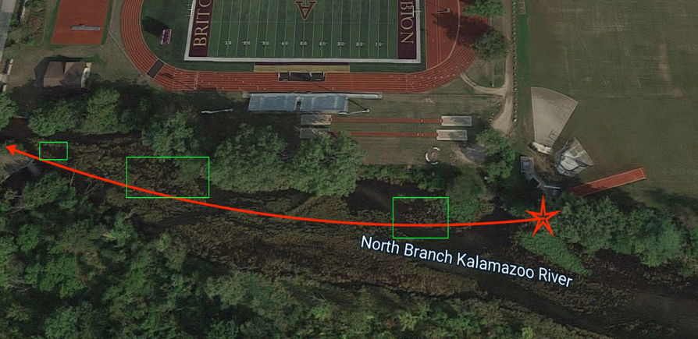
During the beginning of the summer of FURSCA, the rest of the sample from fall of 2020 were observed through the use of a taxonomic identification key. After some observational work, I deployed my collectors into the Kalamazoo River with the help of Dr. Cahill. We placed these collectors in a certain section of the Kalamazoo River, this section started from the beginning of the football field to the bridge (image to the right). The wild rice is represented by the green rectangles.
This time we placed ten more collectors; in case we lost some samples. This innovation came in handy, since the water level in the river was low this year. We left the collectors in the Kalamazoo River for two weeks. Once the two weeks were completed, we gathered the collectors and then preserved them in ethanol. This final step allowed me to have time to look through each sample, since it takes me a day to look through 3 samples. The same observational method I used in the fall samples was used when I looked at the summer’s sample.
After using the taxonomic identification key, I transferred the written data into excel. I used Shannon's equation to determine the diversity of each site. This helps us determine the commonness of species. Along with diversity, we used the richness index. Richness is used to determine the biodiversity of the ecosystem observed. Also, as the level of diversity index increases, the level of richness increases too.
The data collected from both Fall of 2020 and Summer of 2021 demonstrate a high diversity index of macroinvertebrates in the wild rice sites (Figure 1, Figure 4). Not only is the diversity high in the wild rice, but the level of richness is as well (Figure 2, Figure 5). This indicates that the wild rice provides a stable environment for the macroinvertebrates. We know that macroinvertebrates are an important food resource for many prey species, and they play a key role in the nutrient cycle of many aquatic ecosystems. Although much is not known about the wild rice itself, the rice is known to grow in shallow areas where there’s a soft bed and high nutrient level. Therefore, the macroinvertebrates not only have a stable and protective environment to thrive from, but they also help provide the important nutrients that the wild rice needs. Besides using the data to calculate the diversity and richness, I used the same data to calculate the biotic index. The biotic index is used to define the health and quality of the water. Through the biotic index, we can determine which macroinvertebrates are tolerant to pollutants. The biotic index is calculated by identifying specific macroinvertebrates, meaning that not all macroinvertebrates from the sample are used. The samples collected from 2020 and 2021 come from two different seasonal months, fall and summer. Despite the seasonal difference, the water quality of this section of the Kalamazoo River had an average score of 2. This infers that the quality of water is fair throughout the two seasons. Overall, we can conclude that wild rice has a huge impact on the population of macroinvertebrates, but more importantly, more collections of macroinvertebrates is needed to understand the overall relationship between the macroinvertebrates and the wild rice.
During week seven of FURSCA, I spent time doing fieldwork in California. The same process was done in the freshwater marsh in California, where I placed collectors and left them out in the field for two weeks (image below). Due to my permit, I was only able to have ten collectors out in the freshwater. After the two weeks were done, I repeated the preserving process. During the final week of FURSCA, the samples of the Ballona freshwater marsh were shipped to Albion College, in order to use the same instruments to observe and identify the macroinvertebrates. This observation will be completed in the Fall of 2021.
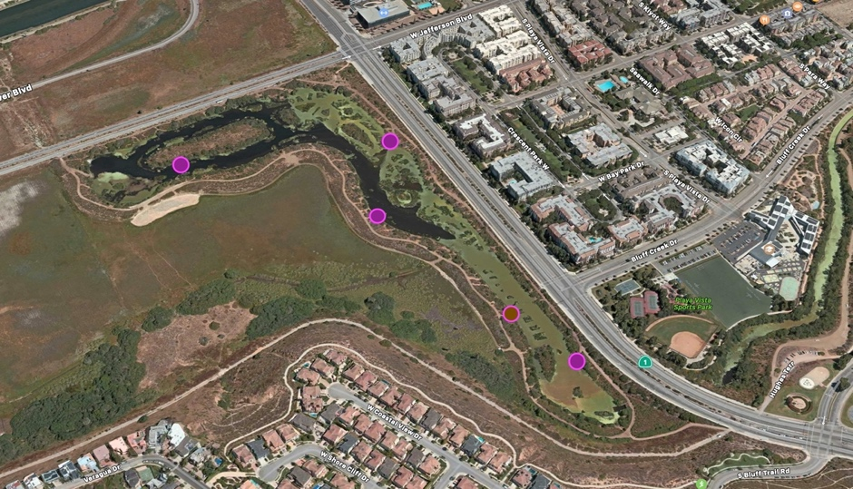
After FURSCA, I anticipate turning this research project into my senior thesis and participate in the Elkin Isaac student research symposium. One of my final goals, connected to my FURSCA project, is to expand my knowledge in R language, in order to provide my thesis paper with more statistical data. Dr. Cahill and I hope to expand this research, in order to provide a long-term understanding of the wild rice, especially now that climate change affects their prosperity.
I am very thankful for the opportunity to take part in FURSCA this summer. I had the opportunity to gain more field work experience and data analysis expertise, which are amazing skills to have for grad school. Thanks to FURSCA, I was able to virtually hear different research studies and be inspired.

Special Thanks to:
The FURSCA Committee, especially Renee Kreger and Vanessa McCaffrey
FURSCA Sponsors, especially Kenneth Ballou, '47 for Research Endowment

Dr. Abigail Cahill for the help and support throughout FURSCA
Jason Raddatz for the support and access to the Whitehouse Nature Center

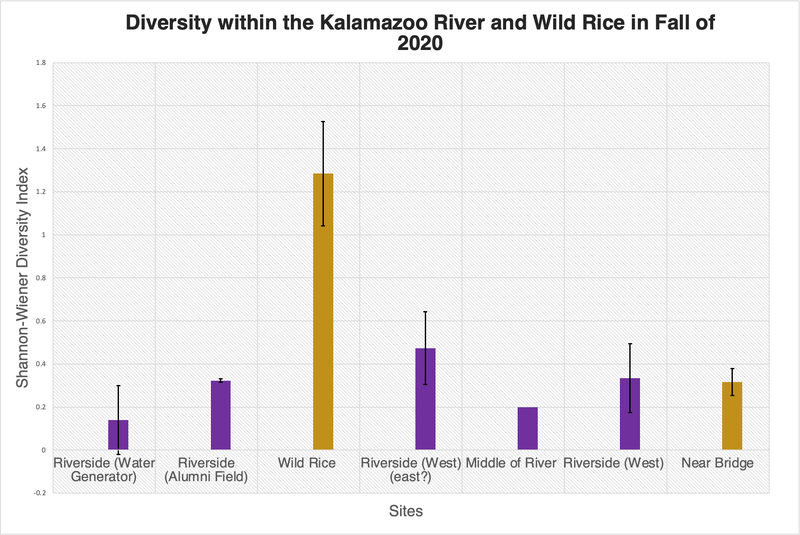
Figure 1: (Below) Demonstrates how there’s high diversity within the wild rice section (golden bars).
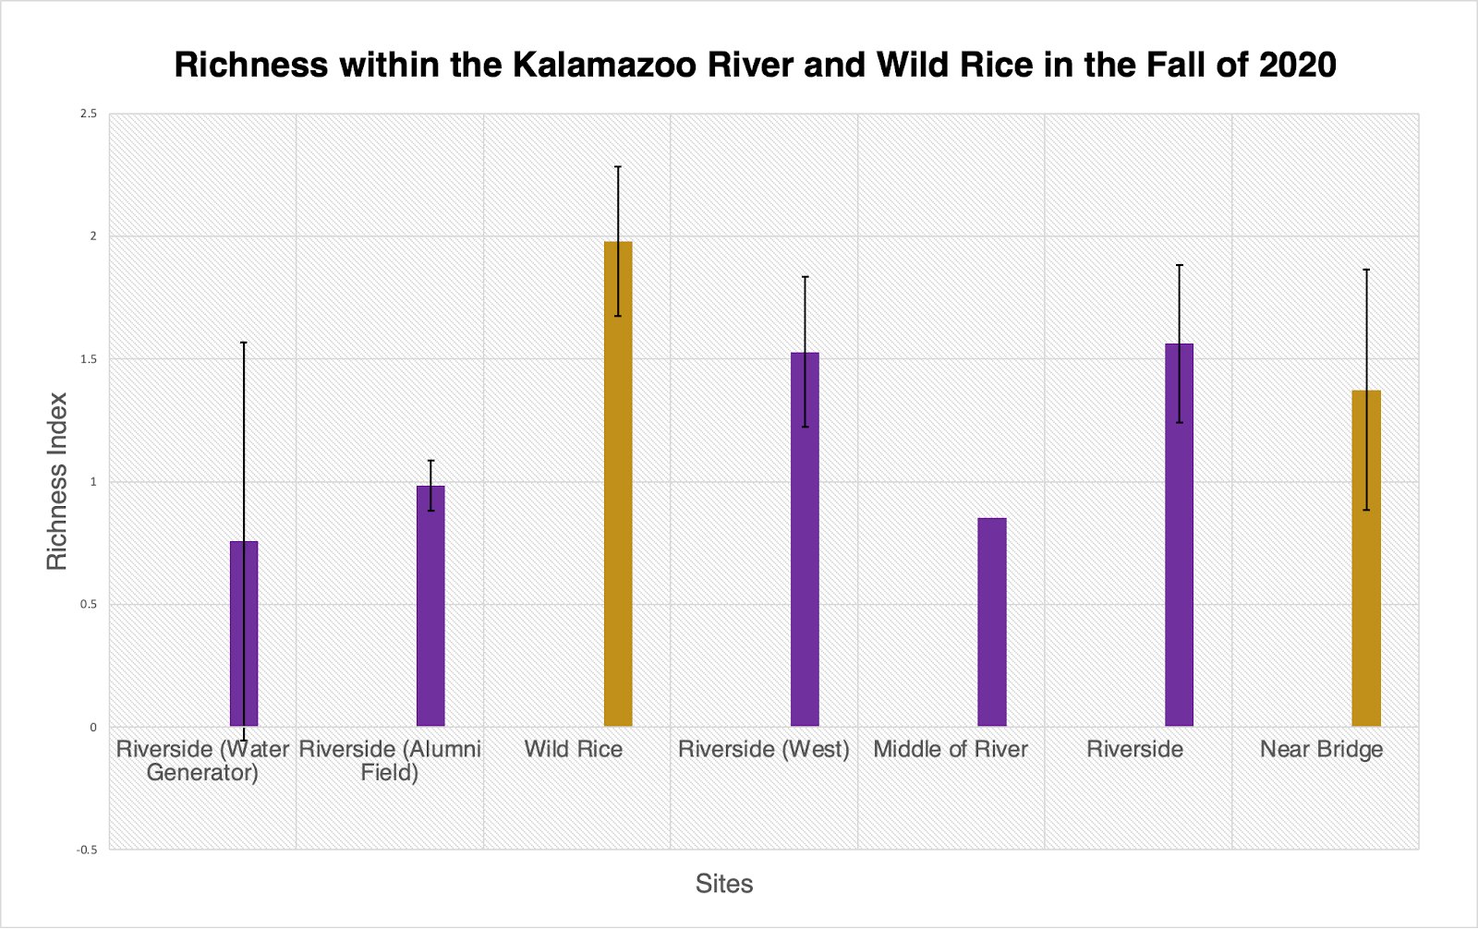
Figure 2: (Below) Demonstrates levels of high richness within the wild rice section (golden bars).

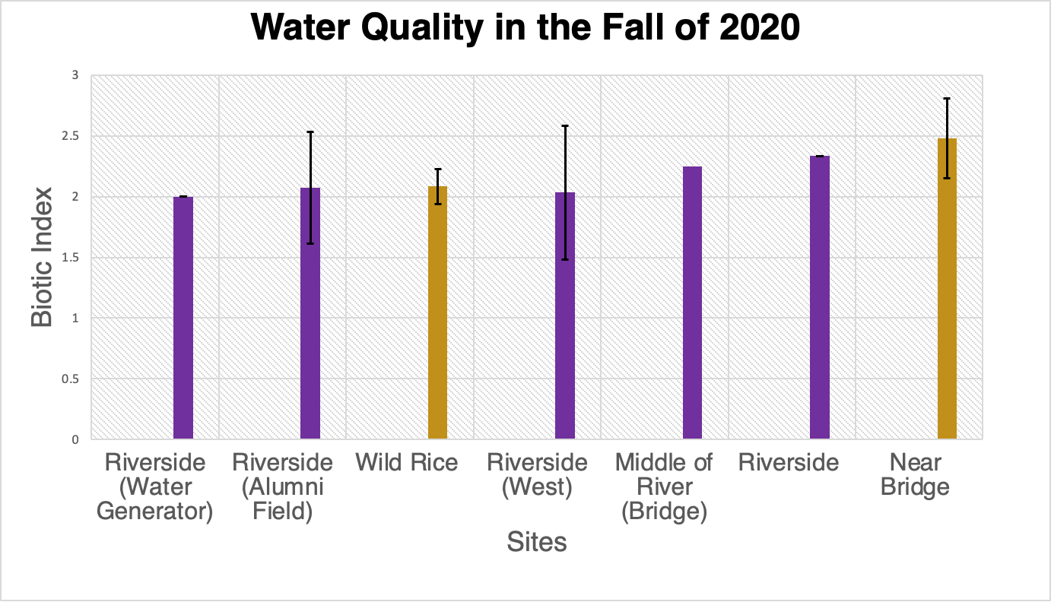
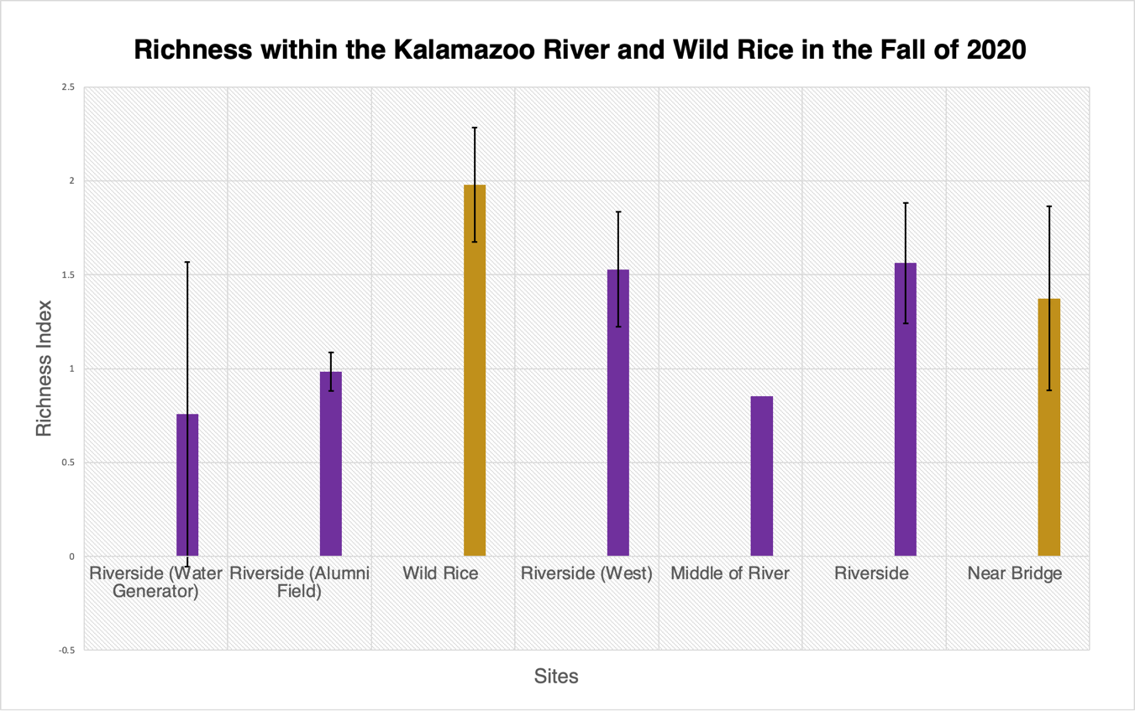
Figure 3. Demonstrates the water quality of the selected section of the Kalamazoo River
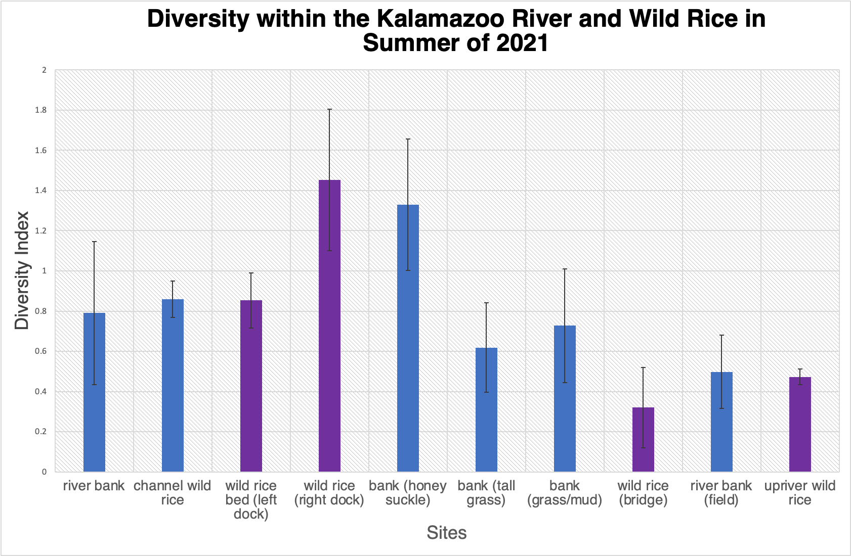
Figure 4. Demonstrates the high diversity that exist within the wild rice (purple bars).
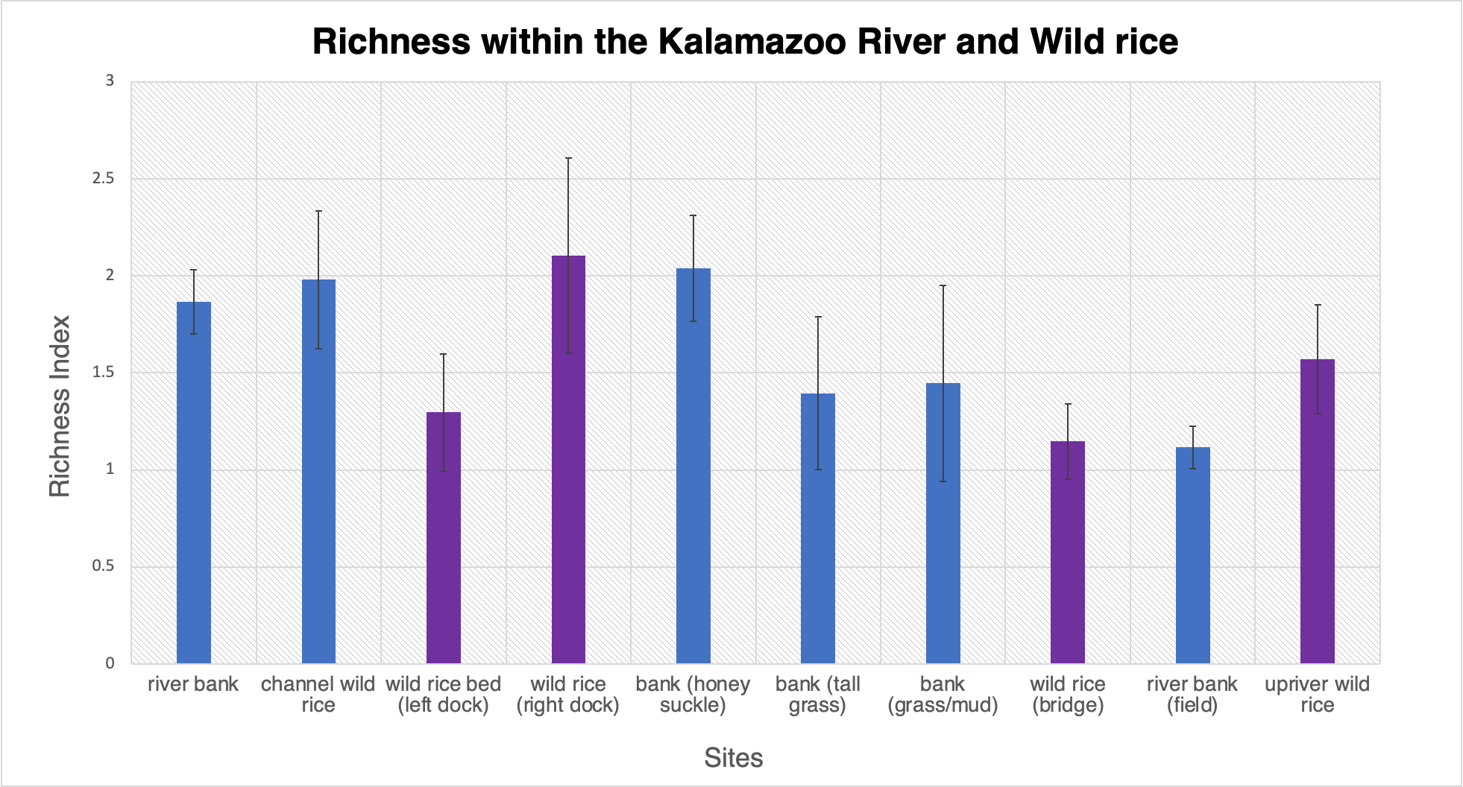
Figure 5. Demonstrates the high richness that exist within the wild rice (purple bars).
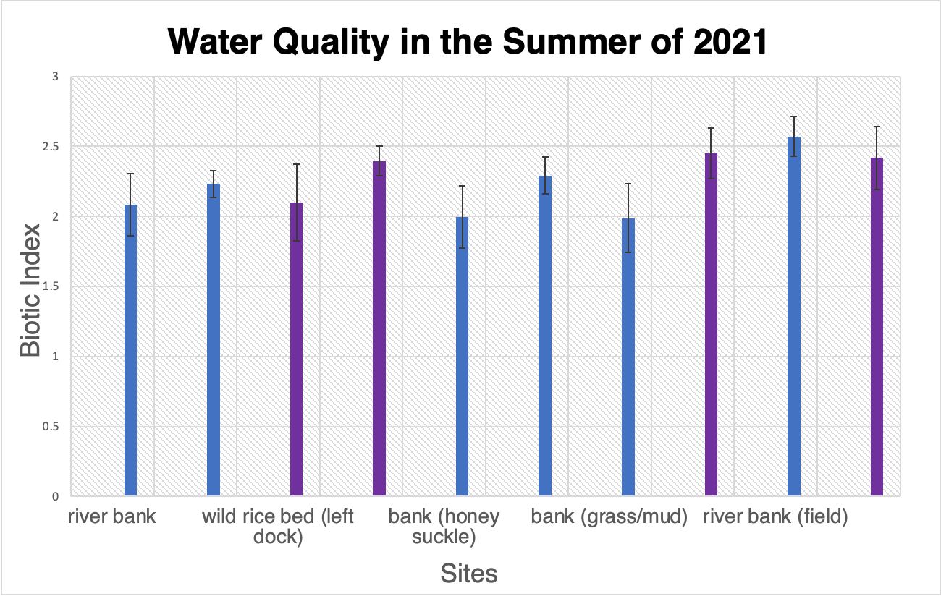
Figure 6. Demonstrates the water quality of the section of the Kalamazoo River in the summer.

Appendix I

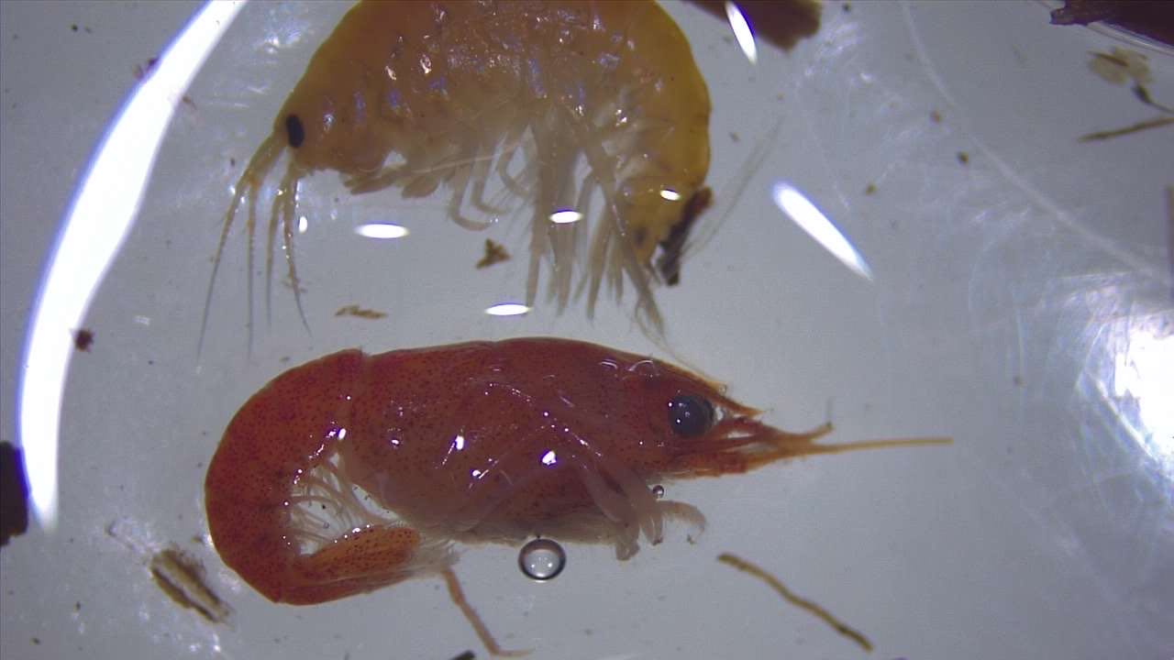
- An imagine of the most common macroinvertebrates, Amphipods and Crayfish
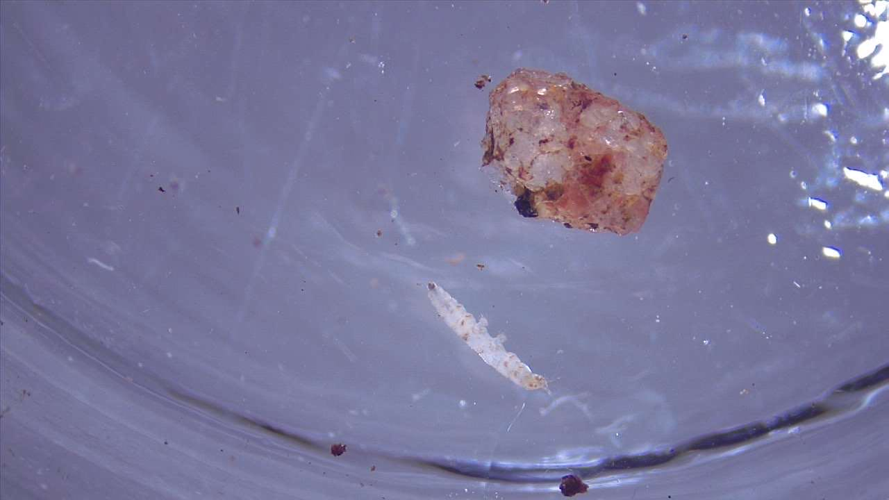
- An imagine of one of the smallest macroinvertebrates
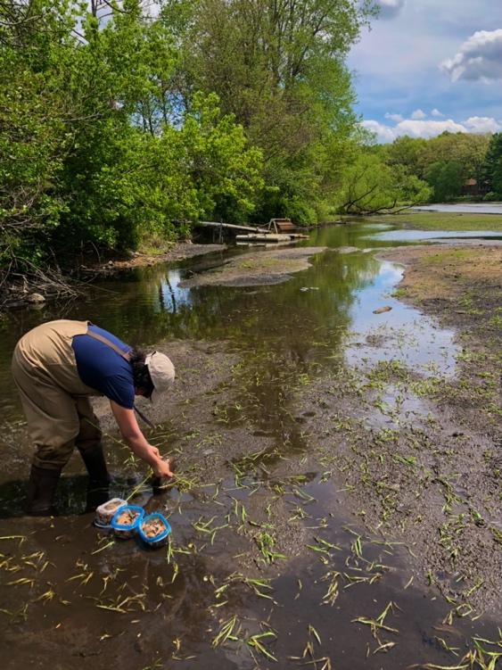
- Imagine: Deploying collectors in the summer of 2021
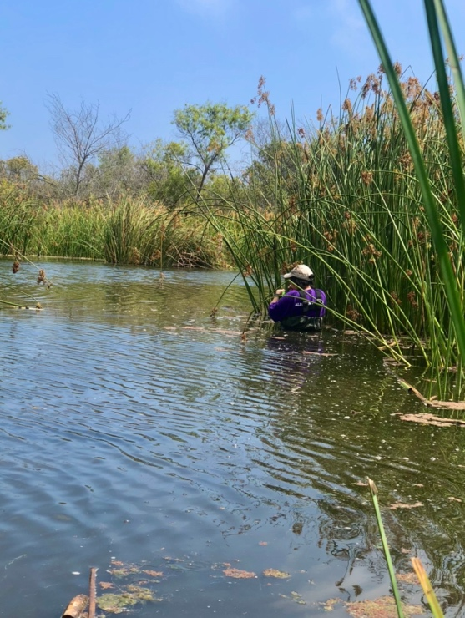
- Imagine: Deploying collectors at the Freshwater Marsh, California
- The image shows an example of statistical data analysis in R language. I’ll be using this software for my thesis.


