Anna Crysler
End of Summer Report 2021

For my FURSCA project this summer, my overall goal was to generate antimicrobial nanobodies using directed evolution of nanobody-displaying yeast cells. Antimicrobial resistance poses a major threat to public health globally, and deaths due to antimicrobial resistance are expected to increase 14 times what they are today by 2050 if no urgent action is taken (1). In general, the timeline to develop novel antimicrobial drugs can take years—this is not ideal since bacteria and other microbes can rapidly develop resistant mechanisms that render antimicrobials useless. Directed evolution is a promising way to tackle this drug timeline problem since it harnesses the power of evolution (selecting the “best” from a largely diverse population) but does so rapidly. New antimicrobials can be selected and produced in a matter of weeks, allowing these drugs to keep up with the speed of microbial resistance. For my project, I planned to isolate a lipid from the cell wall of bacteria to use as my antigen in directed evolution. After isolating the lipid, it can be labelled with a molecule called biotin which binds strongly to streptavidin. Using streptavidin-covered magnetic beads and cell sorting techniques, I can isolate nanobody-displaying yeast cells that bind to the isolated lipid, creating a nanobody that can bind and destroy the cell wall of bacteria.

Throughout the course of my summer research, I was able to isolate Lipid II from Staph epidermidis bacteria and express and purify proteins that are needed to quantify and biotinylate this lipid. Isolating the Lipid II from S. epidermidis required me to grow 1.5 liters of bacteria and follow a series of extractions that removed cell debris and other biomolecules from the one type of lipid that I desired. Since lipids can stick to glass and plastic, I used Teflon coated centrifuge tubes for the final extractions (Figure 1). I sent a sample of the extracted Lipid II to the University of Michigan to be analyzed via mass spectrometry which will indicate if I have successfully isolated and purified the correct compound. This is an important checkpoint because in order to move forward to the directed evolution steps of this process, I need to know for sure if I have in fact isolated Lipid II.

To express and purify the proteins needed for quantification and biotinylation, I reached out to Dr. Rob Nicholas at the University of North Carolina at Chapel Hill. He has used the same proteins in work published by his lab, so he was able to send me bacteria that harbored the plasmids that would express the proteins I needed. This was incredibly helpful and saved me a couple weeks of work in which I would have had to subclone the genes for these proteins before expression and purification. Once I received these bacteria in the mail, I expressed and purified Penicillin Binding Protein 4 and 5 (PBP 4 and 5). PBP5 will be used in a reaction to quantify Lipid II, allowing me to know how much lipid I have isolated. PBP4 will be used to add the biotin molecule to the lipid, allowing me to later perform directed evolution against Lipid II. Figure 2 shows the two purified proteins that I will use in the next steps of my work.

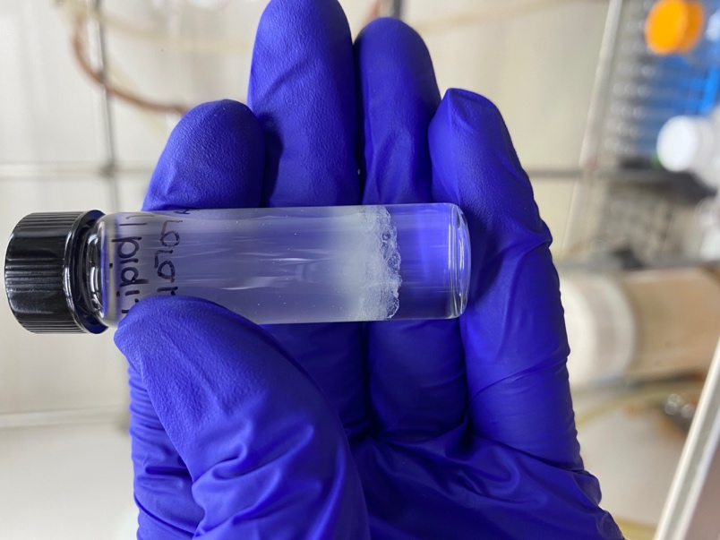
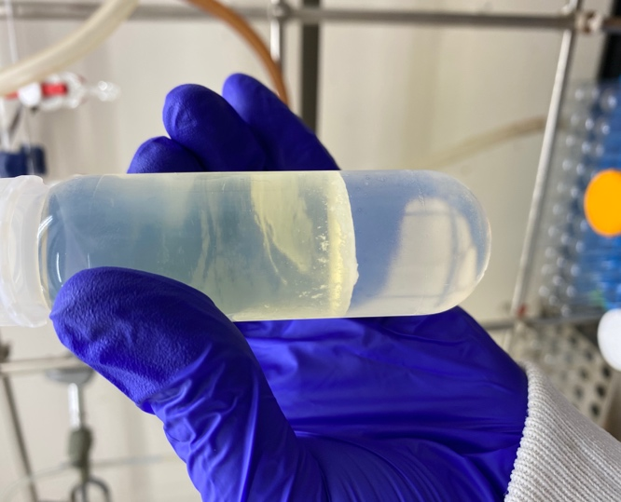
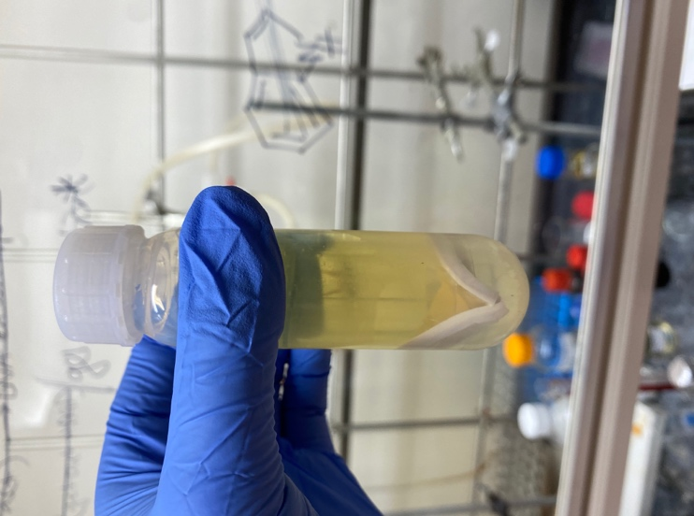
Interface
Supernatant
Figure 1. Extraction of Lipid II using organic and aqueous extractions. From left to right, I removed the supernatant from the first tube which removed cell debris from the solution. Using aqueous and organic solvents, a lipid interface layer was created in the second tube, and in the third tube, a final extraction removed Lipid II from other nucleotides in solution.

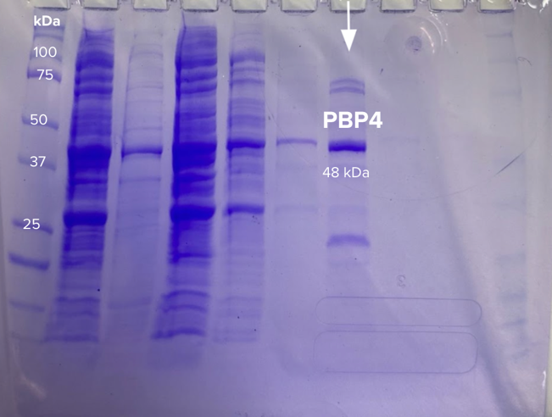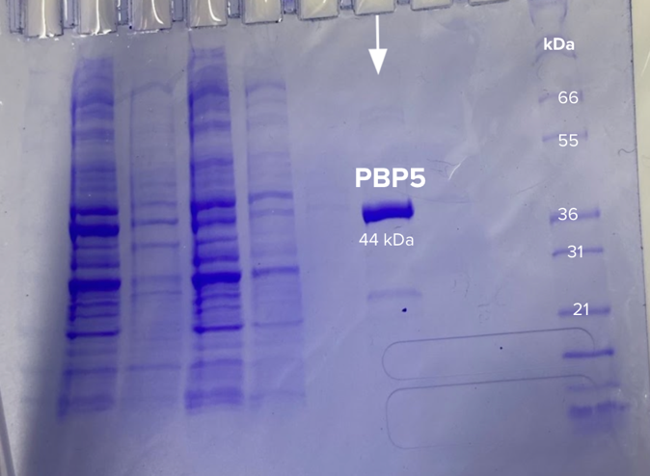
Figure 2. Purification of PBP4 and PBP5 using protein purification columns and SDS PAGE electrophoresis.

The work I was able to complete this summer greatly accelerated my goal of performing directed evolution of nanobodies against Lipid II. I will continue my work during the Fall 2021 and Spring 2022 semesters and use this research to write my Honors thesis. I will present my research at the Elkin Isaac Research Symposium in 2022 as well as the annual Experimental Biology (ASBMB) meeting in 2022. After I graduate, I plan to attend graduate school in biochemistry or chemical biology to pursue a doctoral degree. Without the experiences I have had this summer, I would not feel confident moving into graduate school and pursuing a career in research. I was able to learn a lot about my research preferences and what I may want to study in my future academic years. I would like to include a huge thank you to FURSCA for making this summer an awesome experience while navigating pandemic barriers, to ASBMB for recognition and funding through the Undergraduate Research Award, and to Dr. Rohlman and Dr. Streu for helping me in lab and supporting me in all aspects of advancing my academic career!

To the Bruce A., '53 and Peggy Kresge, '53 Endowed Science Fellows:
Thank you for giving me the opportunity to participate in Albion’s FURSCA program this summer. Coming out of the pandemic with many opportunities being put on hold, I am incredibly grateful to have been able to conduct research in the lab. This summer provided many benefits that will greatly influence my future education and research endeavors. Thank you!

References:

- Chaib, F. New report calls for urgent action to avert antimicrobial resistance crisis. World Health Organization. World Health Organization.

