E. Amber Blackmon
FURSCA
Summer 2021

Royal Mews End of Summer Report

Over the summer, I compiled information about the Royal Mews and encoded the resulting research for the Map of Early Modern London’s (MoEML) website. The website has an interactive map that allows the viewers to click on its various features. Some of these features have information, others do not and are called stubs. At the start of my project, the Royal Mews was a stub. If there was time left over, I would repeat the process for the falconry, the equines, and the streets in London to provide viewers a better idea of their presence in London during the 1500s and 1600s. This information would provide the history of the Royal Mews, the falconry use within London and England, the use of working equines in London, and the streets near the Royal Mews. For the project, I looked into documents, mostly digital, using predominately ProQuest, JSTOR, and Google Scholar to find relevant documents published within the late 1400s to 1700. More contemporary texts that discuss the same time period were also accepted. Once the information was compiled and edited, the information would then be encoded using oXygen XML Editor for the MoEML website.
The goals of the Royal Mews and equines were completed, but the falconry and London streets goals were not achieved. The Royal Mews is encoded and ready for submission. At the time of this document’s submission, the equine-information is ready for final editing before being encoded. In contrast, I was hoping to find a link between falconry and London rather than English falconry. While the latter is interesting, and perhaps beneficial for future research endeavors, the falconry sub-project was supposed to provide more information about falconry in London. Thus, unless I find a link to connect my compiled information about general falconry with London, I do not have anything falconry-related to submit to MoEML. The streets near the Royal Mews, however, seem promising because I have found some information about streets such as Haymarket and Hedge Lane. Consequently, the equine, falconry, and streets subprojects will hopefully be materials for future research in the coming fall or spring semesters.

I am happy to report that I have four informational paragraphs about the Royal Mews. Figure 1 is a screenshot of my “final draft” before I encode the information into oXygen; Figure 2 is a screenshot of the encoding, specifically the Royal Mews’ References section. Additionally, I am excited that I have a multitude of paragraphs about the working equines, which differed from riding horses since the former were used for carts or as beasts of burden rather than being ridden. The paragraphs include brief explanations of the similarities, differences, and uses of the different horse types. This is exemplified in Figure 3, which has excerpts of passages about hackney and coach horses.
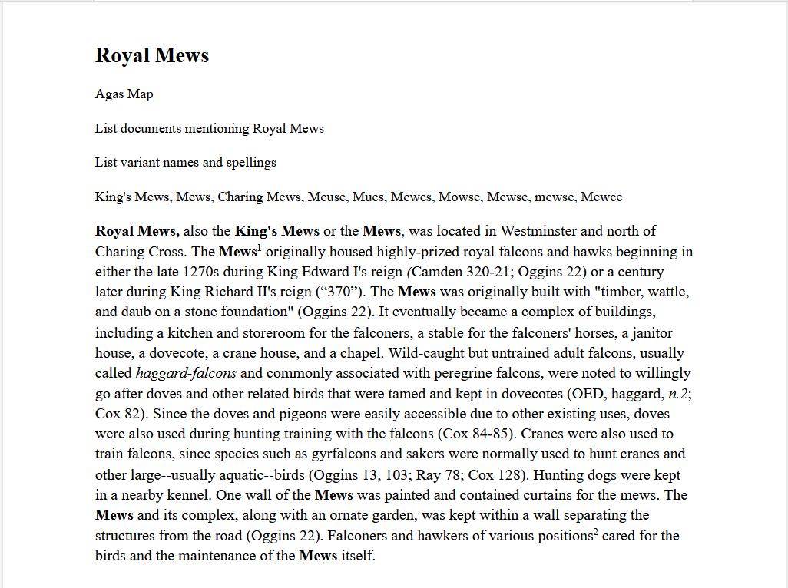
Figure 1: A screenshot of Royal Mews Google Doc’s first paragraph

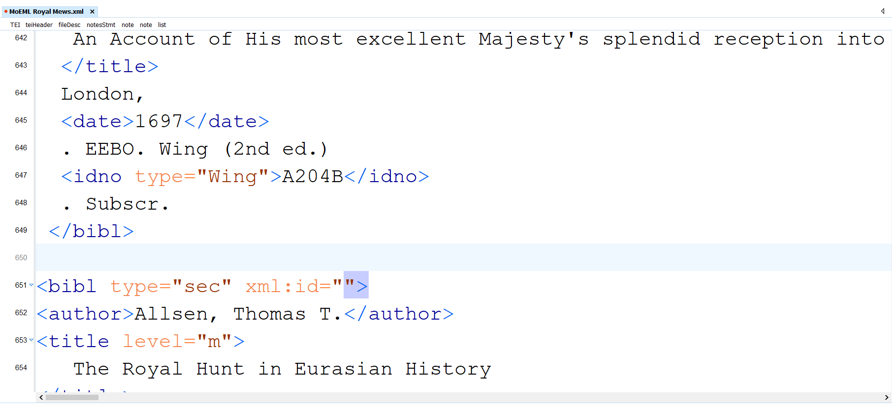
Figure 2: A screenshot of oXygen XML Editor Royal Mews’ References section

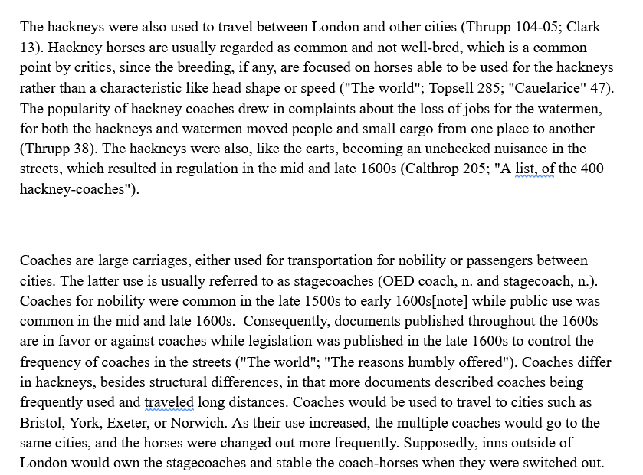
Figure 3: Excerpts of the Hackney-horses and Coach-horses passages pre-final editing

My research has taught me the process of encoding and XML, which is an important skill set beyond Albion College. XML has the advantage of being accessible on any platform and advantageous for online document submissions and large collaborations. Being able to encode gives me a tool that may prove useful to future employers if documents need to be encoded. Also, encoding is a component of web design and could be a potential career option should the opportunity present itself.
This project has also taught me to observe what is present and absent in written record. In my research, I noticed gaps in the records. The Royal Mews, for instance, is not recorded on a regular basis, like contemporary records developing timelines or progressions of a landmark. Instead, early records would only note the Royal Mews when a significant event happened, such as a fire or conflict. Otherwise, the Royal Mews were absent in records, so details are hard to obtain. The presence of horses and the payroll of the Royal Mews was easy enough to find, but details about the Mews’ design, maintenance, and appearance are absent in texts. Similarly, the use of cart-horses are more noticeable in the late 1600s as more legislation is published to regulate street traffic. However, the appearance of cart-horses in the late 1600s documents does not mean that those horses appeared in London streets in the late 1600s. Rather, the cart-horses were first used in London much earlier, but only became a problem later and consequently more frequently recorded. These observations have taught me to be more mindful of what is written down in records and the context of when documents are published, for I now wonder how easily our understanding of history can change with the absence or addition of records. This wonderment also serves as a reminder of the complexities of history, and how the past, especially older pasts, are rarely simple.
An additional life-changing experience was the reminder of trying to find a balance between throwing myself into a project but not burning myself out. This was a problem in school but became more noticeable in this project because the FURSCA set-up mimics the work-force structure. If I do not find a way to balance between future work and burning myself out, then work will become more difficult and I will be without the flexibility that the College provides its students to address burnout. However, my experience with this project has motivated me to try different techniques to obtain results without becoming mentally drained and talk with others on how they address similar balance problems.
I currently plan to have my project presented at the Elkin Isaac Symposium. If my research is published by MoEML, then my project will potentially be accessible to a wider audience. I am most appreciative for this amazing research opportunity and would also like to thank the Harriet E. Elgin, ’36 Endowed Fellowship for providing their support in this project.

